Institutions Matter, Lines Don't: Unveiling Mexico’s Redistricting Process

Alejandro Trelles, Micah Altman, Eric Magar, and Michael McDonald
August 31, 2023

Abstract
Redistricting tends to be a highly politicized process because it shapes the translation of votes to seats. Since Mexico adopted automated redistricting in 1996, the electoral management board (EMB) has successfully rebalanced districts while considering partisan input in a closed-door environment. Despite these processes have been welcomed by political actors, the electoral bureaucracy has recently been accused of making biased decisions against the ruling party (MORENA). In this article, we examine whether popular criticisms are justified and if there is any evidence of administrative wrongdoing. Our analysis reveals that redistricting matters––as an institution––and that plans suggested by parties have surprisingly marginal partisan effects.

Keywords: electoral integrity, electoral management, redistricting, party strategic interaction, algorithmic optimization, gerrymandering.

1. INTRODUCTION
Democratic electoral institutions translate the people’s will, expressed by their votes, into the selection of representatives that enact government policies. In redistricting—the periodic drawing of electoral boundaries to achieve ostensibly apolitical goals such as balancing districts’ populations—the causal chain may be reversed. Politicians may draw electoral boundaries to allocate voters among their districts in ways affecting the number of legislative seats parties expect to win, the careers of incumbents, and the representation for racial and other minority communities.
With so much at stake, scholars find the redistricting strategy known as gerrymandering may distort representation (Cox and Katz 2002, Engstrom 2006, Erikson 1972, Tufte 1973). Most studies focusing on the partisan implications of redistricting are based on the US experience (Lublin 1999, Shotts 2003, Gelman and King 1994, Abramowitz, Brad, and Gunning 2006, Cain 1985, Brady and Grofman 1991) or well-established democracies (Rositter, Johnston, and Pattie 1997a,b and Jackman 1994, Handley and Grofman 2008). Overall, these studies find that: i) redistricting substantially affects political representation, ii) partisan actors and legislators act with sophistication to maximize their expected seats through gerrymandering, and iii) they are generally effective in doing so – unless responsibilities are devolved to a strong independent agency, such as a court or commission.
To what extent do these findings generalize to third-wave democracies? According to the Ace Electoral Knowledge Network, approximately two-thirds (107 out of 165) of countries that redraw electoral geography do so through a de jure independent electoral management body (EMB) or a specialized electoral boundary commission. How are de jure independent EMBs across the Global South constraining gerrymandering? What types of rules and procedures are being used by electoral agencies to redefine electoral boundaries? What have been the consequences of partisan inclusion and allowing them to participate in redistricting? Answers remain uncertain because only a handful of studies examine the internal workings of electoral agencies or the consequences of including political parties in redistricting across third-wave democracies.
Mexico is an ideal case to study these questions because the country’s Instituto Nacional Electoral, known as INE since 2014 (formerly IFE), acquired complete formal independence from the executive in 1996. Overall, the EMB has managed to consolidate its reputation as an outstanding agency. When redistricting outcomes have been occasionally contested, the court’s rulings have systematically backed INE’s technical decisions (Saldaña and Cervantes 2020). Although the INE remains a formally “non-partisan” EMB, the institution’s true independence has been increasingly questioned by President Andrés Manuel López Obrador (AMLO) and leading members of the Movimineto de Regeración Nacional (MORENA), Mexico’s ruling party established in 2014. In 2022, for instance, AMLO’s administration proposed a constitutional reform to renew INE’s executive board, appoint commissioners through popular vote, and transition from a mixed-member electoral system to a fully proportional one. More recently, in 2023, the ruling party passed an electoral reform in Congress, popularly known as “Plan B,” which intended to reduce the EMB’s budget and modify its administrative structure, affecting the workings of the electoral civil service (Reyes and Marván 2023).
Mexico’s democratization phase in the 1990s is closely tied to a series of electoral reforms that altered the opposition parties’ capacity to access legislative representation (Lujambio 2000 and Weldon 2005). In the late 1970s, for instance, the country transitioned from a purely majoritarian electoral system to a mixed-member electoral one (MMES), gradually increasing the presence of opposition parties in the legislature through the adoption of a proportional representation (PR) tier. MORENA’s attempt to alter the country’s electoral system in 2022––by reducing the size of the legislature and transforming the country's MMES into a fully proportional one––motivates our inquiry focusing on the association between the electoral system’s majoritarian component and the distribution of seats in the legislature.
While the EMB’s reputation as a truly independent agency remains high and political parties have remained formally represented within the electoral bureaucracy––serving as a fire alarm mechanism (McCubbins and Schwartz 1984), a comprehensive study of redistricting is necessary because i) the 2017 redistricting round preceded MORENA’s dramatic victory in 2018 (the now ruling party was established in 2014 and substantially increased its legislative presence from 14 majority seats in 2015 to 218 in 2018); ii) the process has been carried out in a closed-door environment, and recent studies show that the EMB has systematically deviated from publicly advertised rules (Trelles et al. 2023); and iii) while parties have actively engaged in the process formulating hundreds of alternative plans, there is no comprehensive study analyzing the political consequences of redistricting in Mexico.
In this paper, we construct a novel database previously unavailable outside IFE comprising all of the plans proposed by political parties in the 2013 and 2017 redistricting rounds. Our analysis of Mexico’s redistricting process in the last two decades allows us to evaluate if mainstream assumptions of party behavior from the US literature are generalizable across the Global South. Specifically, we examine three overarching questions about redistricting in Mexico:

Q1. How much does redistricting matter? In general, what effect does redistricting as an institution and the process itself have on seat allocation? And specifically, to what extent was redistricting responsible for MORENA's dramatic victory in 2018?

Q2. Which parties gained a substantial advantage through the manipulation of redistricting? And generally, are the outcomes for the parties consistent with the dominant theory of redistricting, based on the US experience?

Q3. Do rules matter ––to what extent did each component of the redistricting institution and process affect outcomes? Specifically, to what extent were outcomes driven by the parties' development and selection of specific maps, INE's rules and process for evaluating plans, or the constitution's requirements for redistricting?

Our analysis offers unique insights into Mexico’s redistricting, the internal workings of an independent election board, and the ways in which parties strategically interact with electoral bureaucrats. We show MORENA's 2018 legislative victory is unrelated to how lines were drawn and that no party was systematically affected by the redistricting process. This is a curious finding in light of the extant redistricting scholarship in developed countries. Contrary to key assumptions derived from the US redistricting literature, we find strong evidence Mexico’s redistricting affected only marginally electoral outcomes and that the process appears highly constrained by core rules based on drawing districts from secciones (a geographical unit equivalent to the U.S. census tract ranging from 1,000 to 3,000 individuals), compactness, and a requirement to preserve municipal integrity. Further, the evidence implies that the growing criticisms of administrative bias within Mexico’s EMB are misplaced and that recent proposals for reform are misguided.
We structure our paper as follows. First, we describe how redistricting works in Mexico and how parties and bureaucrats have engaged. Second, we analyze the effect redistricting has on seat allocation, compared to a purely proportional system; we evaluate the impact that redistricting––changing district lines––has had on seat redistribution among parties; and we discuss the degree to which rules are constraining the variation we observe in electoral outcomes. Third, we focus on a specific state, the Yucatan, to complement our large-N analysis and illustrate the partisan dynamic during the implementation phase, as well as the effect that rules had on the plans considered by the EMB. We conclude by summarizing our main findings and providing some insights related to the implications of our findings.

2. MEXICO’S REDISTRICTING CONTEXT AND EXPECTATIONS
Since nationwide redistricting authority was granted to Mexico’s EMB in the early 1990s, redistricting has been implemented in 1996, 2004, 2017, and 2022. Overall, the country’s political elites perceive redistricting as a process exempt from the aggressive gerrymandering observed in many U.S. states. Historically, the court’s rulings have portrayed its implementation as a technical process rather than a politically motivated one. They show that “redistricting rules and procedures have been systematically validated a priori by all political parties” (Saldaña and Cervantes 2020: 295). Additionally, the process has helped to substantially improve democratic representation in some areas, such as the considerations afforded to indigenous communities (Sonnlentier 2001 and 2013, Meng and Palmer-Rubin 2017, and Trelles 2017).
Compared to the U.S., where most states have not fully delegated redistricting to an independent board and are still experiencing high levels of politicization (McDonald 2004 and 2008, Cain 2011), Mexico’s EMB has innovated beyond its neighbor. It has employed customized automated algorithms to find redistricting plans deemed optimal on a priori criteria and has invited political parties to react by suggesting alternative plans (Trelles and Martínez 2008 and 2012, Magar et al., 2017, and Trelles et al., 2023). Overall, the high levels of partisan engagement during the 2013 and 2017 cycles reveals that parties are interested in redistricting. While in 2013 parties proposed a total of 522 alternative plans, they formulated a total of 463 counter-proposals during the 2017 redistricting round.
We illustrate Mexico’s redistricting in Figure 1. The process begins with the executive board defining the legal criteria and appointing a technical committee (TC) responsible for producing computer-optimized plans––the first scenario––for all thirty-two states. It ends with the board’s approval of the third––final––scenario suggested by the TC. In between, political parties represented within the electoral board engage in two sequential rounds by offering counter-proposals in each state. Plans are compared to one another using a cost function where each map is assigned a specific value––a lower cost represents a map that satisfies more optimally the restrictions imposed by the EMB (e.g., population balance, geometric compactness, municipal integrity, and traveling time).
In the first round of interaction, the TC evaluates plans suggested by local and national political parties, compares them to the first scenario according to an explicit scoring function, and selects the best solution, which becomes the second scenario. In the second round of interaction, the TC compares the party-proposed plans to the second scenario and selects a third scenario that is ultimately considered by the board (Trelles et al., 2023).

Figure 1. The Redistricting Processes in Mexico

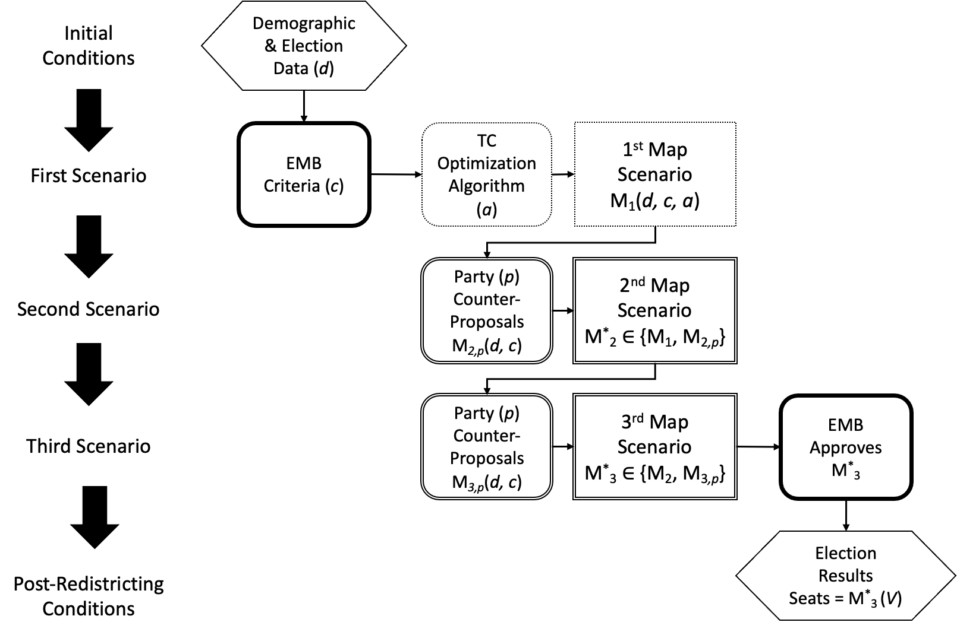
Note: The figure depicts the redistricting process focusing on maps (M) as the unit of analysis. The sequence on the left represents the first, second, and final scenarios created for each of the thirty-two states. The diagram on the right shows the time by the direction of arrows; Subscripts 1-3 represent the first, second, and third stage of the process, respectively; The letter “M'' represents a specific map that has been configured based on the demographic data (d) and the EMB's criteria (c). While the first scenario is configured via algorithmic optimization (a), the second and third scenarios are impacted by two subsequent rounds of partisan interaction (p). All proposals are constrained by restrictions d and c. The asterisk (*) denotes the winning map that has been selected by the TC from the specific subset of plans that were considered by the EMB in each state.

Plans are affected by the difference in (ex-ante) procedural decisions between redistricting processes (e.g., the EMB´s definition of rules and criteria, the operationalization and instrumentation of the redistricting process), and by the (ex-post) effect introduced to the initial plan by the two different phases of strategic partisan interaction. In this paper, we examine both the ex-ante and ex-post effects across the 2013 and 2017 redistricting processes. This comparison allows us to better understand the degree to which human interaction, compared to adoption of certain rules and procedures, affect redistricting outcomes.
While the two processes are similar there are some important differences. The bureaucracy, for instance, modified the internal implementation of the process in 2017. In 2013, the bureaucracy completed all phases of the redistricting process, but IFE´s executive board rejected the proposed district boundaries during the last stage (depicted as “EMB Approves M*₃” in Figure 1). The process then became intertwined with the 2014 electoral reform and the 2015 elections were held using the 2004 plans.
In 2017, the board repeated the process using the same legal framework and census information, but operationalized redistricting criteria in a slightly different way. Instead of optimizing with four restrictions (i.e., population balance, municipal integrity, traveling time, and geometric compactness), the EMB’s technical committee decided to use only two (population and compactness). Furthermore, INE’s Council General adopted a “unanimity rule”––known as criterion 8––instructing the bureaucracy to consider accepting as valid suboptimal scoring plans proposed by the political parties, provided all parties unanimously endorsed them.

3. THEORETICAL EXPECTATIONS AND EVALUATING THE EFFECT OF REDISTRICTING
We derive a series of premises from theory related to the political consequences of redistricting, party behavior, and popular understanding of the process. We operationalize our three main research questions based on the characterization of the implementation we describe in section 2.1.
Regarding Q1––analyzing the effect of redistricting as an institution, we expect the country’s majority tier to have a substantial effect on the seat distribution among parties. Overall, we expect that larger parties that have traditionally managed to have a broad national level of support to be the beneficiaries of receiving a majoritarian seat bonus (Shugart and Taagepera 2018 and Weldon 2001).

Question 1. Redistricting as an institution
Premise 1.1. Compared to a purely proportional electoral system, adopting a majority tier––via a mixed-member electoral system––offers a substantial seat bonus to the larger parties.

To evaluate this premise, in section 5.1, we compare the actual seat distribution to the counterfactual distribution of seats that would have been awarded had the 2021 votes been used to allocate seats using a purely proportional rule, as was initially proposed by the executive in the reform package that was rejected by Congress in 2022.
MORENA was established in 2014 and became the ruling party in 2018. After competing in the 2015 midterm election, it obtained only 35 seats (14 in majority districts and 21 through the PR tier). Three years later, after the 2017 redistricting cycle was completed, MORENA dramatically increased its congressional representation in the 2018 national election. A massive shift in the levels of support from the PRI gave MORENA 306 seats (218 in majority districts and 88 through PR). This radical change motivates us to ask about the degree to which redistricting is behind this landslide victory. If it was, we would expect that the number of seats obtained by MORENA in 2018 would have been significantly different if redistricting had not occurred in 2017––assuming the EMB would have used the 2004 district baseline (status quo).

Premise 1.2. The number of seats obtained by MORENA in 2018 would have been significantly less if redistricting had not taken place in 2017.
Regarding Q2, the political consequences of gerrymandering in the United States motivate our expectation that the high levels of partisan engagement in Mexico’s redistricting had a meaningful impact on electoral outcomes. Following Mayhew’s (1974) framework, we assume parties behave as rational, self-interested, and rent-seeking maximizing agents every time they suggest the EMB adopt an alternative plan. To match these behavioral expectations with the observed outcomes, we analyze engagement on two levels: higher level (strategies) and lower level (actions).
Following the revealed preference analysis (RPA) logic, we expect that activity in these two levels to be aligned with the outcomes (Samuelson 1948, Varian 2006). On the one hand, a party’s strategy to engage should vary depending on the characteristics of each party and the environment of electoral competition at the state level. On the other hand, their actions should respond to either a vote share or seat maximizing strategy (e.g., formulating an alternative solution when the expected return is positive compared to the status quo––the algorithmic solution presented as the first scenario or the plan selected by the TC as the second scenario). This activity is depicted in Figure 1 by the two lined quadrants defined as M_{2,p}, and M_{3,p}, which represent the total share of counter proposals that were submitted by political parties.
We expect the 2013 and 2017 final––winning––plans to differ substantially from the algorithmic solutions from their respective year. That is, if parties successfully accomplished their aims by sponsoring plans to maximize their electoral returns, we expect that parties sponsoring winning plans would have significantly increased the number of seats when comparing their seat share with either the status quo or the algorithmic solution. Furthermore, we expect the seat distribution among parties to be different in those cases where a party––or group of parties––endorsed a plan (the two lined quadrants depicted in Figure 1 and defined as M_{2,p} and M_{3,p}) that prevailed over the algorithmic solution.

Question 2. Seat allocation advantage and partisan engagement
Premise 2.1. Parties substantially increased their seat share after redistricting took place (when comparing the seat distribution under the winning plan to either the algorithmic solution or the status quo).
Premise 2.2. Overall, party plans reveal a significant seat advantage compared to their expected return under the status quo (seat maximization strategy).

ALMO accused INE’s electoral commissions of being “puppets of the opposition,” the former ruling PRI and PAN parties. We evaluate this public controversy with respect to partisan advantage realized by all political parties through redistricting. If the map selection process during the partisan interaction phase (depicted as M_{2,p} and M_{3,p} in Figure 1) had systematically favored a specific party (e.g., former ruling parties such as the PRI or PAN), we expect to observe a distortion in the seat distribution disfavoring MORENA when comparing the partisan character of the algorithmic plan with the plan selected by INE.

Premise 2.3 The former ruling parties (the PRI and the PAN) received a significant advantage over MORENA after redistricting took place (comparing the seat difference between algorithmic and winning plans).

Regarding Q3 ––analyzing the degree to which the rules, criteria, and implementation of the process constrained the variation in the allocation of seats, the interaction of multiple dimensions affecting the outcome makes it extremely difficult to isolate the effect of each component (e.g., partisan interaction, selection of the criteria to generate plans, the rules adopted to evaluate them, or the constitutional requirements for redistricting). Although this complexity limits our ability to offer a comprehensive answer, we can identify how some of these dimensions contributed to constraining the outcomes.
Given that redistricting implies adjusting the number of districts assigned to each state based on population shifts over time, we first analyze if there was an incremental effect associated with the specific redistricting processes used in 2013 and 2017 when comparing the seat distribution to the 2004 baseline cartography. We expect the cartographic renewal to have a substantial impact on seat distribution because each state is governed by different political dynamics.
For example, the population in the State of Mexico (known as EdoMex), which is the country’s largest state and was ruled by the PRI until 2023, has been systematically increasing in the last two decades. In contrast, Mexico City, which has traditionally been a stronghold of the left-wing PRD and of MORENA since 2018, has lost a significant number of habitants, causing the country’s capital to lose an important number of districts in that same period. These effects can be estimated by comparing the expected distribution of seats under the algorithmic plans to the counterfactual distribution that would have occurred if districts had not been redrawn (status quo).

Question 3. The constraining effect of rules, criteria, and implementation
Premise 3.1 The seat distribution among parties under the algorithmic solution will significantly differ from the one observed under the status quo.

Given the way in which “INE set the table” by adopting a set of rules governing the process, we then ask i) how much room was left for parties to maneuver (M_{2,p} and M_{3,p} in Figure 1) and ii) what part of INE’s setup constrained the effect of the alternative plans suggested by parties? To answer these questions, we use a sección level analysis to evaluate the proportion of secciones that changed between––and within––the 2013 and 2017 redistricting cycles.
To evaluate the former (parties’ maneuvering capacity), we look at the degree to which the algorithm constrained the capacity of parties to alter plans. Given that the algorithm has become more efficient over the years in identifying lower-scoring plans, we would expect that the parties’ capacity to propose alternatives that significantly deviate from the algorithmic solution has been reduced. To evaluate if this is actually true, we compare the share of secciones that changed after parties engaged in the 2013 and 2017 processes, respectively. Given that the algorithm became more efficient in 2017, we would expect parties to be able to formulate plans with larger deviations in 2013 than in 2017.
We also evaluate degree to which parties were limited by the interaction of redistricting rules and the geographic distribution of their likely supporters to suggesting marginal changes. If this is the case, we would expect to observe a marginal change of secciones when comparing partisan plans to the algorithmic solution ––e.g., less than a 5% change between scenarios.
Additionally, we explore the possible implications of redistricting in a hypothetical extreme scenario (perfect foresight) by looking at the seat differential for each party between their best and worst plans within the universe of plans that were considered by the EMB. If INE’s setup had a pronounced effect on seat distribution, we would expect the difference between the best and worst possible plans to be extremely narrow.

Premise 3.2. Party plans in 2017 moved a significantly lower share of secciones––from the algorithm to the winning solution, compared to 2013 (constraining effect of the algorithmic efficiency).
Premise 3.3. Winning plans do not deviate substantially from the algorithmic solution, < 5% of seccion differentials (constraining effect of the algorithm).
Premise 3.4. The seat differentials within the universe of plans (from worst to best) considered in the redistricting cycle is significant among parties (seat differentials using perfect foresight).

Lastly, to evaluate the latter (if a specific factor of INE’s setup could be constraining the outcome), we analyze if the rule adopted to preserve municipal integrity––or prevent municipal splits––is constraining the variation in the seat allocation among parties. The logic behind the adoption of this rule is that the approximately 2,500 municipalities are geographic entities bounded by administrative, socio-economic, political, and cultural features. Given the high-order priority that the bureaucracy has historically awarded to this rule, and the fact that some municipalities are large enough to provide by-themselves a district-wide plurality for a single party, this criterion has the potential to constrain seat allocation variation. Consequently, we would expect that if there are multiple instances where the municipal party vote is significantly larger than the necessary vote threshold required to win at the district level, this dimension would limit the political implications of changing district lines.

Premise 3.5. The party vote, within municipalities that are required to be kept whole within a district, is larger than the necessary winning vote threshold for a substantial number of municipalities.

In the following sections, we describe our data collection process, and then we proceed to analyze the overall political implications of redistricting as an institution, the effect partisan engagement had on seat distribution outcomes, and the degree to which rules were constraining the process.

4. DATA COLLECTION
To evaluate the political consequences of redistricting––on the three dimensions we outline above––we cleaned, compiled and organized internal data provided to us by INE with all publicly available information related to the rules, criteria, and the evaluation methods used by the electoral bureaucracy to create redistricting plans during the 2013 and 2017 redistricting rounds.
We constructed a unique dataset––using R’s Tidyverse format––comprising the 2,369 plans considered during the 2013 and 2017 redistricting rounds. For each state, we first collected the cartography associated with the 2004, 2013, and 2017 redistricting cycles. This includes the cartographic breakdown at the state, municipal, district, and seccion levels. Second, from INE’s online redistricting tool, we collected all the plans that had been submitted by political parties. Third, INE provided us with a spreadsheet containing the cost associated with each plan that was evaluated by the TC during the multiple stages of the 2013 and 2107 processes (including the algorithmic solution, the solutions generated during the two rounds of partisan interaction, and the final plan). We systematized this information and linked the cost to each plan. Fourth, we obtained publicly available electoral results for the 2015 and 2018 legislative elections, which had been previously curated by Magar (2018).
We used this data structure to build a series of counterfactual scenarios that allow us to compare the hypothetical seat distribution under the two redistricting cycles using different electoral results. Our analysis of micro-level data––such as the number of counter-proposals each party submitted at different stages, levels, and years–– enables a comprehensive comparison between a state’s baseline cartography (status quo cartography based on 2004 plans), the algorithmic solution, the most optimal––lowest-scoring–– plan, and the intermediate and final scenarios adopted by the bureaucracy. This analysis offers a unique opportunity to evaluate if the redistricting process––including party strategic interaction––has affected electoral outcomes. It also offers us a way to analyze if changes between the two redistricting cycles are confounded by party-learning/interaction effects and if partisan interaction had any impact on the distribution of seats.

5. RULES MATTER, LINES DON’T: POLITICAL IMPLICATIONS AND INSTITUTIONAL CONSTRAINTS

5.1 Does Redistricting in Mexico Matter?
The gradual transformation of the country’s electoral system was instrumental for Mexico’s democratic transition (Lujambio 2000). The country moved away from a predominantly majoritarian system by introducing proportionality in the 1960s. Opposition parties had been marginalized from congressional representation in the 40s and 50s because of vote dispersion across states and the absence of a compensation mechanism. As a consequence, Mexico adopted a mixed-member electoral system (MMES) in 1978. Elites decided to increase the proportional representation (PR) tier from 32 (out of 200) to 100 (out of 400) seats in the legislature. Two years later, the Cámara de Diputados adopted its current configuration and increased the PR tier to 200 (out of 500) seats.
To evaluate the effect of redistricting as an institution, we compare the seat distribution among parties between the current MMES and a hypothetical purely PR system. Columns two to five in Table 1 depict the valid number of votes and seats under the current MMES. The sixth column estimates the number of seats each party would receive in a purely nationwide PR system. The last column on the right lists the seat differentials between the two systems.

Table 1. Mixed-Member Electoral System (MMES) vs. purely PR seat allocation in La Cámara de Diputados (2017 boundaries with the 2021 electoral results)

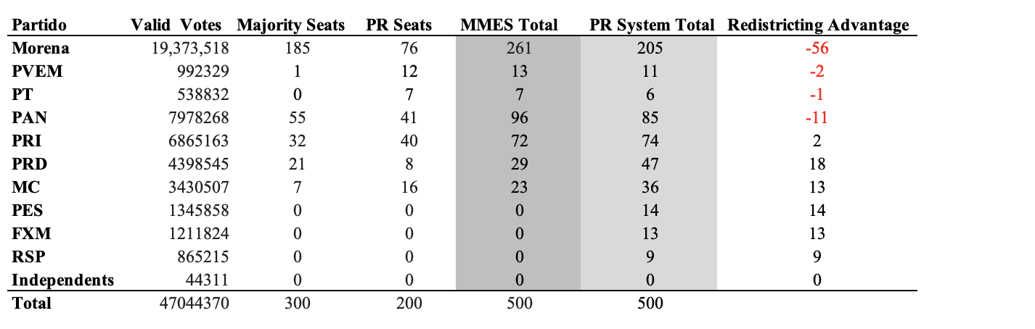
Note: Table elaborated by authors with information from the INE.

The results show that if Mexico used a nationwide PR electoral system, the balance of power in the legislature would be quite different. Based on the 2021 turnout, for instance, smaller parties traditionally obtaining no more than 10% of the seats in both tiers, such as the PRD, MC, PES, and FXM, would have substantially increased their congressional representation (e.g., compared to the average number of seats they usually get under the current MMES, the PRD would have obtained 47 seats, instead of 29, MC 36, instead of 23, and the PES and FXM 14 and 13 seats, instead of 0). In contrast, the former dominant PAN would have lost approximately 9% of its seats (decreasing from 96 to 85), the PRI vote share would have remained practically the same (from 72 to 74), and the largest party––MORENA––would have lost over 20% of its seats (decreasing from 265 to 205).
These differences confirm Premise 1.1. and show the substantial impact the SMD tier––or the institution of redistricting––has on political representation. It demonstrates how larger parties––previously the PRI and now MORENA–– systematically tend to benefit from a seat bonus under the current MMES (Molinar and Weldon 2001 and Weldon 2005).

5.2 Do Lines Matter?
Under the dominant theory of redistricting in political science, parties are assumed to behave as rational, self-interested, and rent-seeking maximizing agents (Mayhew 1974). We find some support for this assumption in the private statements of the partisan actors ––who described to us their strategy in the 2004, 2013, and 2017 processes. PAN’s former representative at the National Oversight Committee (CNV), for instance, confirmed that once the TC shared with them the algorithmic solution for each state, in consultation with the party’s national headquarters ––the party’s Comité Ejecutivo Nacional (known as CEN) used previous electoral returns to rank secciones based on their level of competitiveness and allowed the party to make “informed decisions.” When formulating a plan, the former right-wing ruling party was allegedly prioritizing the formation of districts with those secciones where they had a clear advantage trying to “maximize their vote share, while beating the cost function.”
What success did parties achieve in carrying out these self-stated goals? To assess the impact of the changes in the country’s electoral geography after the 2013 and 2017 redistricting cycles, we analyze the hypothetical seat allocation among parties in the case the process had been different or if it had not happened at all (Jackman 1994). For both processes, we compare the status quo (if redistricting had not happened) with three different types of plans: i) the algorithmic solution (first scenario), ii) the best lower-scoring plan during the interaction phase, and iii) the plan that was adopted by the EMB (third scenario). In the next subsection (5.3) we offer a “perfect foresight” analysis to evaluate what would have happened if each party had been able to force adoption of the most favorable map among all valid maps proposed.
Table 2 depicts the different counterfactual results for the 2013 and 2107 processes in four different quadrants. The first two quadrants (top to bottom) are based on the 2015 electoral returns and show the seat distribution using the 2013 and 2017 electoral districts, while the remaining two (on the bottom) are based on the 2018 election results.

Table 2: Counterfactual scenarios for the 2013 and 2017 redistricting plans based on the 2015 and 2018 elections

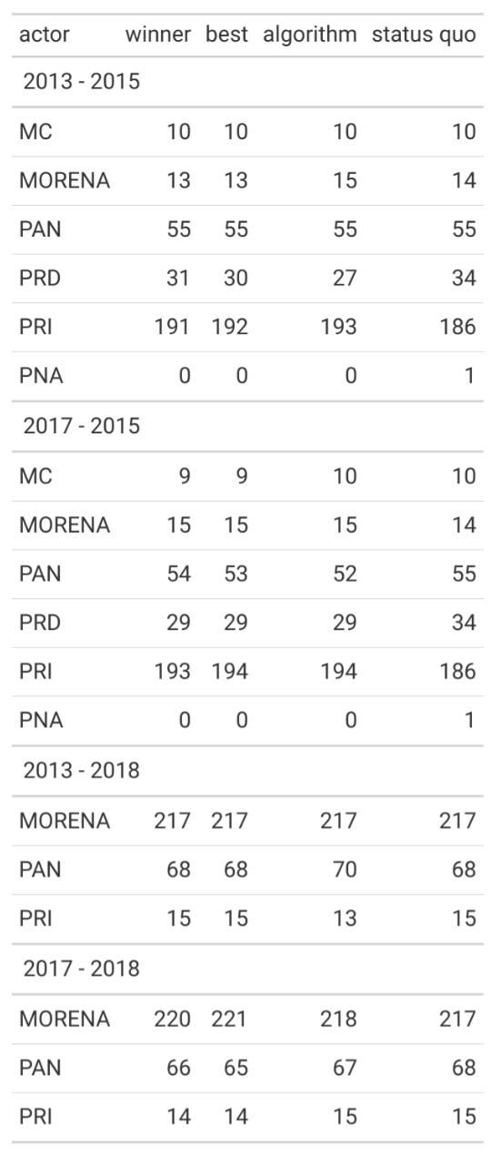

Note: Table constructed by the authors. The first column depicts the actor that suggested a plan. The winner column lists the seat allocation for each party with the plan that was selected by the TC. The best column lists the seat distribution if the lowest-scoring plan had been adopted. The algorithm column lists the seat allocation if the algorithmic solution (first scenario) had been adopted. Lastly, the status quo column shows the seat distribution among parties if elections had been conducted with the 2004 map.

Surprisingly, these counterfactual scenarios reveal the limited effects of boundary choice. That is, district lines––as they have been drawn with the rules, criterion, and implementation described above––had a marginal impact on the overall distribution of seats among parties. The effect of redistricting––when comparing the algorithmic solution with the status quo––is marginal, which is evidence against Premise 3.1. Furthermore, results show that if redistricting had not taken place, and the 2018 election had occurred under the 2004 district baseline, MORENA would have practically obtained the same number of seats (218 vs 217), which is evidence against Premise 1.2.
The results in Table 2 shows that the maximum counterfactual change to any party's seat allocation was at most 3.7%. That is, even if redistricting had not happened in 2013 or 2017, results would have remained almost the same. The PAN, for instance, obtained 55 majority seats in the 2015 election with the 2004 plan (status quo). This same party would have obtained exactly the same number of seats under the three hypothetical scenarios (algorithm, best, winner solutions) during the 2013 redistricting round. In the 2018 election, this same party––the right-wing PAN––obtained 54 seats with the 2017 winning plan, and would have obtained 53 seats if the best solution had been adopted, and one less––52 seats––if the EMB had selected the algorithmic solution. We consider this evidence against Premises 2.1 and 2.2.
In contrast, the institution of redistricting––described in the previous section––reduced the major party seat share by over 21%. The largest positive difference we identified due to a specific selection of boundaries was for the PRI, which won 5 and 7 seats in the 2013 and 2017 processes, respectively (using the 2015 turnout and comparing the winning and algorithmic plan with the 2004 baseline). The most affected party by the drawing of new lines was the PRD, which only lost 3 and 5 seats when comparing the same cycles and based on the 2015 election results.
When comparing the 2013 and 2017 winning solutions using the 2015 election results, we found that parties were losing or winning a maximum of two seats (e.g., MORENA and the PRI won two seats each, while the PRD lost 2 with the 2017 plan). Similarly, when analyzing the seat difference with the 2018 turnout we found that MORENA won only 3 districts, while PAN and PRI only lost 2 and 1 seats, respectively. The similar distribution of seats using the 2013 and 2017 scenarios indicates that the district boundaries contributed little to the turnaround of party fortunes (contradicting Premise 1.2).
Further, Figure 2 shows responsiveness curves, or shifts across the 2015 election, simulating a uniform vote swing from PRI to Morena. This figure compares the status quo plan (2004), with the 2017 algorithmic and winning solutions (first three graphs from top to bottom) under a hypothetical uniform swing from PRI to MORENA based on the 2015 turnout. The bottom graph shows the number of districts that the PRI would have lost with the same uniform swing with the same three possible scenarios (status quo, algorithmic, and winning plan).

Figure 2. Uniform partisan swing from PRI to Morena
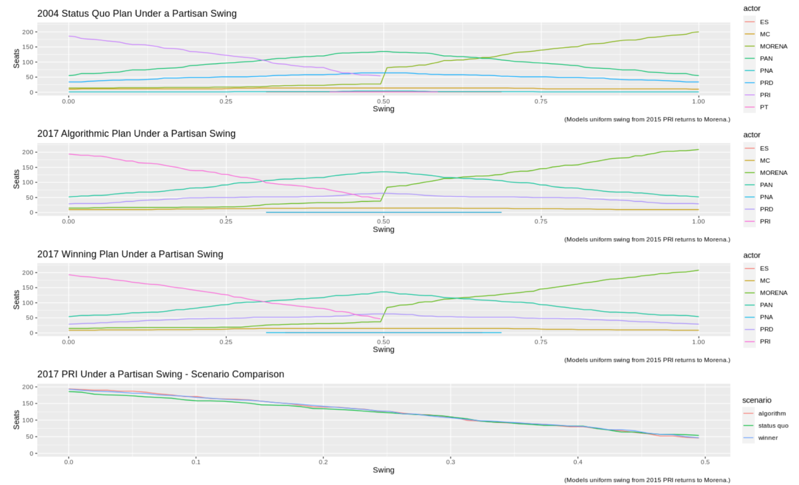
These results confirm that the 2018 MORENA “tsunami” was necessary for it to gain control of the legislature. Morena would have only gained fewer seats if the electoral shift away from PRI after 2015 had been more moderate. As shown in the first three graphs from top to bottom, a shift from PRI to MORENA would have benefited the right-wing PAN if the shift had been extremely large (> 50 %) ––evidence against Premise 1.2.
Additionally, when comparing the lowest-scoring plans of 2013 and 2017 with the winning and algorithmic solutions, we found that seat differentials remained marginal. When comparing the winning plans to the algorithmic solutions, the results demonstrate that the PRI or the PAN did not receive a significant advantage in either round and that MORENA’s seat returns were not affected by the 2017 process (evidence against Premise 2.3). Actually, MORENA received two additional seats (220 vs 218, respectively) ––when comparing the winning to the algorithmic plan in the 2018 election using the 2017 plan.
To further assess the overall impact of the choice of boundary lines on outcomes during the 2013 and 2017 redistricting cycles we identify a “perfect foresight” scenario for each party. Table 3 shows the widest range of outcomes that major parties could have chosen among the valid plans proposed in either 2013 or 2017, given the actual 2015 / 2018 results. That is, we compare what would have happened if the EMB had adopted the best versus the worst map for that party within the total universe of alternative plans that were considered by the TC.

Table 3: Perfect Foresight scenarios for the 2013 and 2017 redistricting plans based on the 2015 and 2018 elections
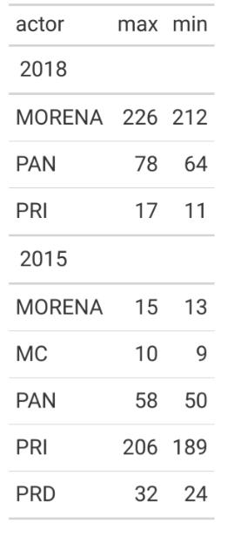

Note: Table constructed elaborated by the authors.

These results reveal that the largest range, by far, is for PRI with the 2015 turnout––a 27-seat difference between the worst-case and the best electoral scenario for this party. The second-largest difference between the worst and the best plan is for both PAN and MORENA with the 2018 turnout – a range of 14 seats for each party. The rest are single-digit differences, where the lowest two are for MORENA and MC––with 2 and 1 seat, respectively–– with the 2015 turnout. Overall, these results show that there was no substantial difference between the parties’ best and worst possible plans considered by the TC (contradicting Premises 2.1 and 3.4).
In sum, while a small seat difference can be crucial for policy outcomes when in gaining majority-control in a two-party contest (Brady et al., 1973, Brady 1978 and 1988, Heberlig and Larson 2012, Campbell 2014, and Rogowski 2016), in Mexico, neither the institution of redistricting nor the choices of electoral boundaries were key factors for establishing MORENA’s national control of the legislature.

5.3. Do Rules Matter?
The evidence above implies that certain parts of the process (i.e., rules of the game, type of criteria, or optimization) or combination of factors are constraining the outcomes (e.g., the largest counterfactual effect we found in section 5.2 was an 8-seat differential for the PRI in the 2015 election, and it completely disappeared in 2018, which is evidence against Premise 3.1). In this section, we use sección differentials to evaluate four premises related to this rule-binding effect. Namely, the rigidity of the process (Premises 3.2, 3.3, and 3.4) and municipal integrity (Premise 3.5).
The outcome of redistricting is a product of the actors’ goals, constrained by multiple rules and procedures (i.e., trying to minimize the population deviation across districts while maximizing geometric compactness and municipal integrity) that interact with the pre-existing electoral cartography (seccions and municipalities) and geographic distribution of voter support for specific parties. Since parties have different (and often opposed) goals, the observed lack of variation in outcomes across party proposals can be inferred to be a result of the constraining effect of cartography, rules, geographic distribution––or an combination thereof.
The public perception of the process, promoted by the bureaucracy, is that once an algorithmic solution is generated, it leaves very little maneuvering room for political manipulation. As the TC has refined the algorithm over the years with the intention of finding scenarios with a lower cost associated with each map, bureaucrats and party representatives have acknowledged that it has become harder for parties to formulate more effective – lower-scoring – counter proposals.
Consequently, a plausible explanation for the lack of variation in the outcome is that it has become harder for parties to formulate lower-scoring plans ––as the optimization has been “fine-tuned” by the bureaucracy. We expect that a decrease in the proportion of secciones changed in every state plan––comparing the algorithmic solutions to the winning plans––between 2013 and 2017 (Premise 3.2). Furthermore, we would also expect that the vast majority of alternative plans suggested by political parties involve a marginal amount of secciones (e.g., < 5% difference of secciones between alternatives). That is, there is no impact on the allocation of seats because when the algorithm finds an “optimal solution,” parties are unable to substantially alter the plans (Premise 3.3).
Figure 3 shows the proportion of secciones (as a proportion of the total number of secciones in a state) that changed between the 2013 and 2017 processes. It depicts the proportion of secciones that changed, comparing the algorithmic solution to the 2004 baseline cartography (status quo) across states in 2013 and 2017 (states that were affected by the apportionment phase – changing the total number of seats – are highlighted in blue).

Figure 3. Proportion of secciones changed at the state level in 2013 and 2017

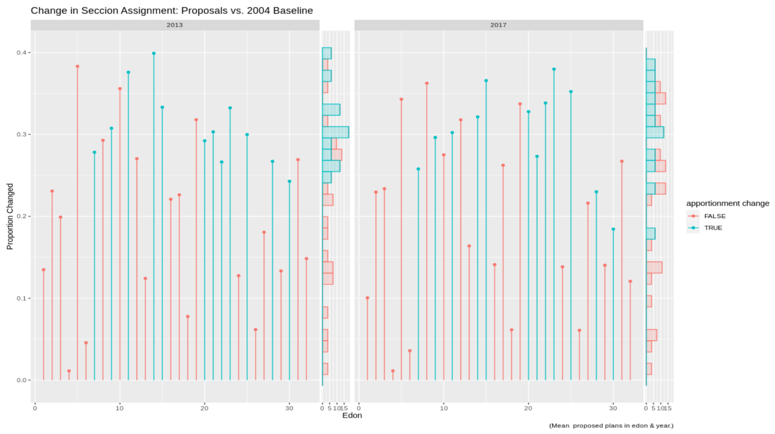
Contrary to what is expected under the popular explanation, results in figure 3 show that many of the states experienced substantial differences in the assignment of secciones between the status quo (2004 baseline) and the algorithmic solution. The proportion of secciones that changed in 2013 and 2017, for instance, oscillates between 20 and 40 percent. Furthermore, this figure shows that while in most cases the average number of secciones changed in every state remained close, in some states the algorithm generated plans with substantial differences (e.g., in 2013, state 10 had approximately a 36% seccion difference with respect to the status quo, while in 2017 it was only 27%). Overall, our results indicate that the share of secciones that changed as a consequence of the optimization phase was pronounced (> 21%) and that the proportional change remained very close across processes. We consider these results to be evidence against Premise 3.2.
Figure 4 compares the change in secciones of the winning plans vs the algorithmic solution in 2013 and 2017. The different colors represent the creator of the winning plan. Results in this figure confirm that while the winning plans supported by a coalition of parties remained almost the same across the 2013 and 2017 processes (8 and 7, respectively), the number of unanimous winning solutions increased significantly in 2017 (from 2 to 10). As a consequence, the proportion of secciones that changed in those states where this type of solution prevailed tends to be higher (e.g., while in 2013 the proportion of secciones changed by a single party in state 27 was approximately 1%, in 2017 this proportion increased to approximately 36%).

Figure 4. Seccion differentials comparing the winning plan vs the algorithmic solution
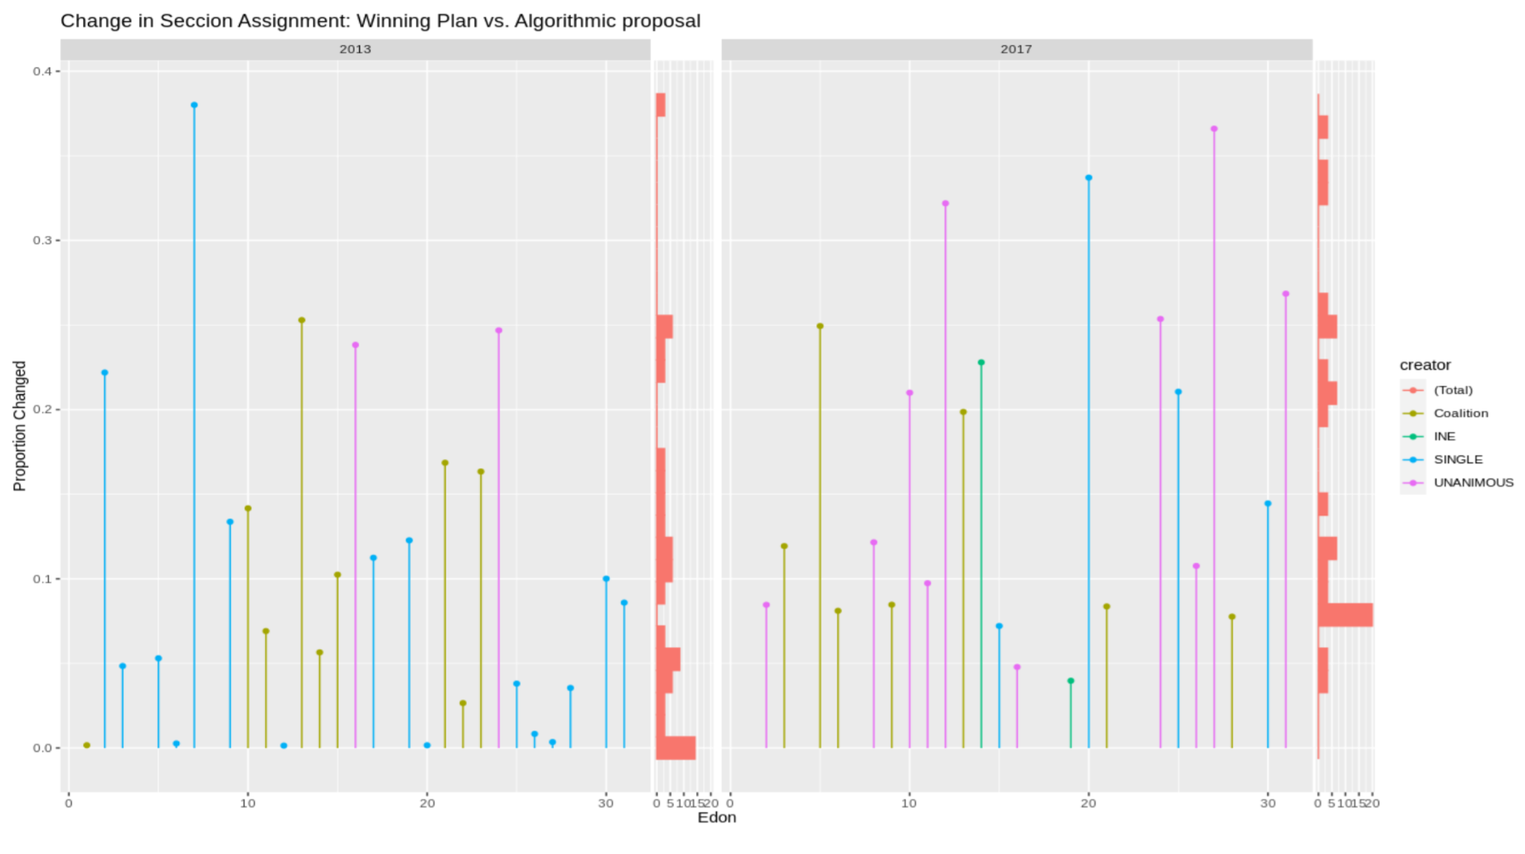
We interpret these results as partial evidence against Premise 3.3 (due to the adoption of criterion 8, but not the efficiency of the algorithm). Furthermore, evidence in Figure 3 clearly suggests that parties could formulate plans with a substantial deviation––of secciones––over time. Surprisingly, these results show that even when the district lines change across states, the overall distribution of seats does not. This remains true across processes and shows that parties are engaging in redistricting for reasons unrelated to seat maximization ––i.e., either because they are getting an unobserved side benefit or because they perceive that being involved in the process will minimize the possibility of being arbitrarily affected by either administrative or political gerrymandering.
Lastly, another plausible explanation for the lack of variation in the observed seat allocation across parties is related to the administrative effort trying to preserve municipal integrity (or prevent municipal splits). Figure 5 depicts in red the median party vote required to win a municipality in each state and also the respective winning vote threshold necessary to win a district for the 2015 and 2018 elections using the 2017 electoral geography.
Figure 5. Municipal vs winning vote threshold at the district level
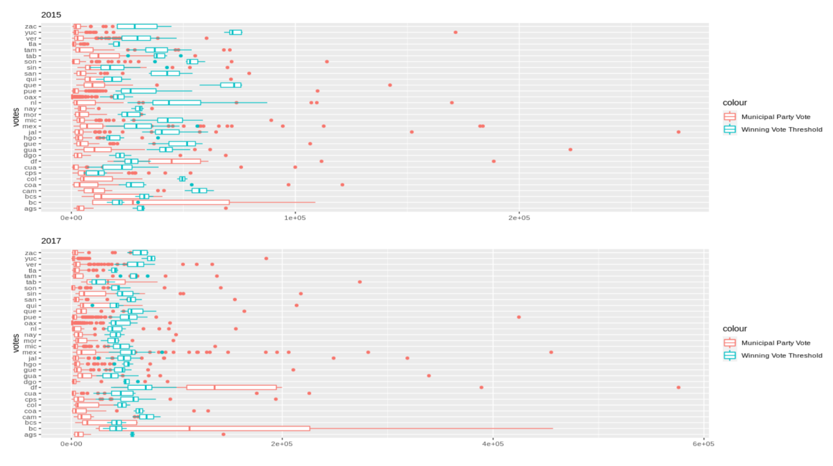
The figure shows support for Premise 3.5. Given the demographic dispersion and the bureaucracy’s effort to preserve municipal integrity (e.g., by using the municipal geography––instead of the secciones––as larger pieces to create districts), municipality splits in most plans are in a small range. However, a substantial number of municipalities exist in most states that, on their own, are large enough to swing the entire district to a party––depicted with red observations (box plots or dots) falling to the right of the median winning vote threshold portrayed in light blue. We found that 37 and 48 districts, respectively, contain unsplit municipalities that could carry the district for a single party by themselves. This implies that the combination of INE's operationalization of the equal population and municipal integrity rules "locked in" sixteen percent of party seats from the beginning of the process -- prior to the plan generation and bargaining process.
Based on case-level analysis (see Section 6) we conjecture that the addition of the compactness rules to the municipal integrity and equal population rules, combined with the constraints of using existing seccion cartography and distribution of voter support account for the lack of variation across expected seats. Given that we are unable to observe counterfactual variation in INE’s criteria (i.e., the choices it made in developing specific plan requirements or the scoring criteria constrained by constitutional requirements), we cannot, however, estimate how would the seat distribution differ if INE's implementation had been different, assuming everything else had remained the same (i.e., distribution of electoral support, cartography, the institution of redistricting, the constitutional rules, and the active partisan interaction phase).
We derive the following conclusions from section 5: i) that the institution of redistricting matters, ii) that the partisan strategic interaction and the mapping negotiations between politicians and electoral bureaucrats had a marginal impact on the distribution of seats among parties, iii) that voter swings, not district lines, explain changes in the allocation of majority congressional seats, iv) that municipal integrity is an important constraint on the variation of seat allocation, particularly in combination with population and compactness constraints, and v) that the interaction of redistricting rules with intra-state political demography (i.e., voter distribution within states) are responsible for explaining the lack of variation we observe on the outcome variable.

6. POLICY IMPLICATION AND THEORETICAL PUZZLES: PARTY BEHAVIOR
In the absence of a substantial seat allocation difference after both redistricting cycles, the fact that parties engaged heavily in both processes remains puzzling––it is not well-explained by the theory developed based on US and UK elections. A first approximation at lower-level actions reveals that parties have an explicit interest in participating in the redistricting process by suggesting hundreds of alternative solutions to algorithmically generated plans. The high level of activity, along with the significant amount of administrative resources spent by the bureaucracy in 2013 and 2017, invited us to explore if their intervention could be justified by alternative explanations to the logic of seat-maximization.
If their actions did not have a pronounced impact on the seat allocation among parties, why did parties engage in redistricting the way they did? In order to answer this question, we conducted semi-structured interviews with party representatives of major parties at the national and state level that were responsible for formulating counter-proposals during the 2013 and 2017 rounds in the southern state of Yucatán. We then analyze five alternative explanations and evaluate some of the hypotheses related to the high levels of partisan strategic engagement (higher level) with the available data.

6.1 The case of Yucatán
We use the case of Yucatán to better understand the pattern of engagement and the way in which parties publicly justified their actions during the 2013 and 2017 redistricting cycles. Further, a microlevel analysis using INE’s redistricting memoir and interviews with party representatives at the state level exemplifies how technical experts evaluated partisan plans and shows how the operationalization of the rules affected the outcome.
We selected the state of Yucatán because this is one of the states where we identified an irregular pattern of play in 2017 involving: i) a universal lower-scoring algorithmic solution, ii) higher-scoring partisan alternative solutions in the second round, and iii) a unanimity solution that is below most of the partisan alternatives in the previous stage, but not all. Figure 6 shows the cost associated with all plans formulated by different across all five stages of the process in Yucatán, namely the first scenario (algorithmic solution), the first round of partisan interaction, the TC’s selection of a second scenario, the second round of partisan interaction, and the TC’s selection of a winning plan (depicted horizontally from left to right).
Figure 6. Redistricting in Yucatán: Stages and Winners
2013 2017
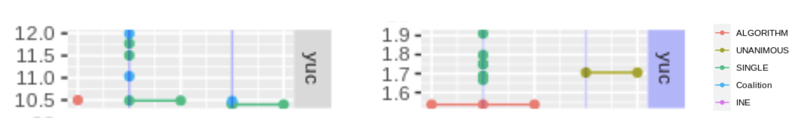

In the case of the 2017 process, the algorithmic solution had an associated cost of 1.53, and six (out of nine) parties suggested six alternative plans through their local representatives at the CLVs and two of them endorsed the lower cost algorithmic solution. The TC argued that given that the algorithmic solution offered the lowest scoring plan, it would select it as the “second scenario.” In the second round of observations, parties coordinated to override the institutional choice and, invoking criterion 8, all nine parties formulated a plan with a cost of 1.705. After evaluating this higher-scoring plan, the TC stated that the “second scenario or the algorithmic solution” still was “the plan with the lowest score and the one that best meets all the technical rules.” As a consequence, experts recommended to the EMB the adoption of the algorithmic solution (1.53) as the final plan. The bureaucracy, however, decided to adopt the unanimous higher-scoring partisan solution instead (1.705).
We find five aspects of this process to be particularly interesting. First, even when the TC recommended the adoption of the lower-scoring plan based on technical criteria, administrative slippage took place, and the bureaucracy decided to adopt a higher-scoring solution based on political reasons, not technical ones. A closed-door bargaining conversation took place among local parties so that they would be able to agree on imposing a higher-scoring solution over the technocratic plan.
Second, the partisan behavior in Yucatán cannot be explained in terms of rational (fully-informed, unbounded, and sophisticated) behavior where parties are aiming to optimize an expected vote/seat curve. The zero-sum characteristics of this interaction make it difficult to understand both the parties’ decision to adopt the unanimity rule and the reversal of PAN’s revealed preference ordering over rounds. These types of decisions are impossible when parties are fully-rational and there are no side payments. Hence, we consider this as evidence that the default rational-maximizing rationale model is violated.
Third, the case of Yucatán reveals that the implementation of criteria substantially constrains the possible outcomes. Given the way that the EMB has interpreted municipal integrity, the city of Mérida was going to be split, and the rest of the districts were pretty much fixed. The municipal integrity rule is limiting significantly the degrees of freedom in the mapping process in this state. When interacting with the compactness rule, it constrained, even more, the degrees of freedom of the algorithm. That is, based on INE’s rules, the city of Mérida had to be split horizontally in order to be minimum scoring (a very similar algorithmic solution was proposed in 2013).
Fourth, the case confirms that parties engaging in the process are capable of, at most, improving competitiveness at the margins. In the case of Yucatán, most of the action took place around the capital, where parties were not expecting to create a major shift but were trying to make Mérida’s southern district more competitive. Although incumbency is generally not considered an important factor in Mexico’s redistricting process, we learned from our conversation with party representatives that there is a correlation between a candidate’s level of support and the township that nominated them.
Lastly, in our conversations with party representatives, we identified a substantial difference between official explanations and real motives. While official explanations, which were submitted as part of the redistricting process, emphasize an allegedly altruistic interest of parties to facilitate certain EMB’s administrative procedures (i.e., poll worker recruitment), both the interviews with party actors and the quantitative analysis are consistent with the rationale that parties had a clear expected pattern of seat/vote maximization when engaging in the process.

6.2 If it's not the seats, what explains the parties’ behavior?
As illustrated by the case of Yucatan, the publicly-stated rationale for proposing district line changes typically, and implausibly, refereed to good-government goals such as explicit redistricting criteria and administrative criteria. In private, based on our fieldwork experience and conversations with both bureaucratic and partisan actors, seat gain was the only acknowledged goal. This suggest a puzzle––if parties intend to gain seats, and were unable to do so through the redistricting process–– why did they continue to participate by proposing hundreds of plans in each cycle?
In this section we propose five alternative explanations for this pattern of partisan engagement. These explanations are i) unusual elections, ii) maximizing the vote share at the margins, iii) side payoffs, iv) limited party capacity, and v) building legitimacy through partisan inclusion. Although the existing data does not point definitively to a single alternative, it favors the final two explanations.
The first explanation––unusual elections––holds that the lack of variation in the allocation of seats is due to atypical electoral results but that if elections had been typical, we would have been able to observe a substantial advantage ––or disadvantage–– for specific parties. That is, parties were expecting that under “normal or average” circumstances, party seat differences would have been radically different. Following the premise of “the PRI did not disappear, it only transformed itself (into MORENA),” which has dominated Mexican electoral politics after the establishment of the left-wing MORENA in 2014.
However, this explanation is undermined by the stability of the predicted results from each plan under partisan swing. As shown in Figure 2 above, the seats-votes response curve is not substantially different whether one uses the status quo, algorithm, or winning plans––and is exceptionally stable. Parties could rationally expect to lose or gain a substantial number of seats under proposes plans only if they expected historically unprecedented vote swings.
The second explanation––maximizing vote share at the margins for winning districts–– is that parties, knowing that their input will not alter the seat allocation in a meaningful way, still play the game, trying to maximize the expected vote share they receive in districts that they win. When asked about their strategy to formulate counter-proposals, party officials and representatives at the National Oversight Commission (CNV) explained that once the algorithmic solutions were revealed in each state, they would cross-reference the maps with previous electoral returns at the sección level, and would formulate plans that would maximize their vote returns within seats they control. If this Premise is true, we would expect the following:

Premise 4. The vote margins for engaging parties in projected winning districts will be higher under the proposed plan compared to the status quo (algorithmic solution from the first scenario or the second scenario selected by the TC).

Table 4 depicts the revealed preference analysis for counter-proposals made by major (PRI, PAN, PRD) and minor parties (MORENA, PVEM, PT, ES MC, PNA) in both years during both stages. The columns offer the summary statistics (mean, standard deviation, and range) for the three metrics we develop to compare plans focusing on vote share, seat, and competitive margin differentials. We also include a composite score that represents the parties' weighted objectives under the standard theoretical model where increases in the following are lexically preferred: number of winning seats > number of competitive seats >, the margin in competitive seats > margin in winning seats.

Table 4. Party counter-proposal – Revealed Preference Analysis

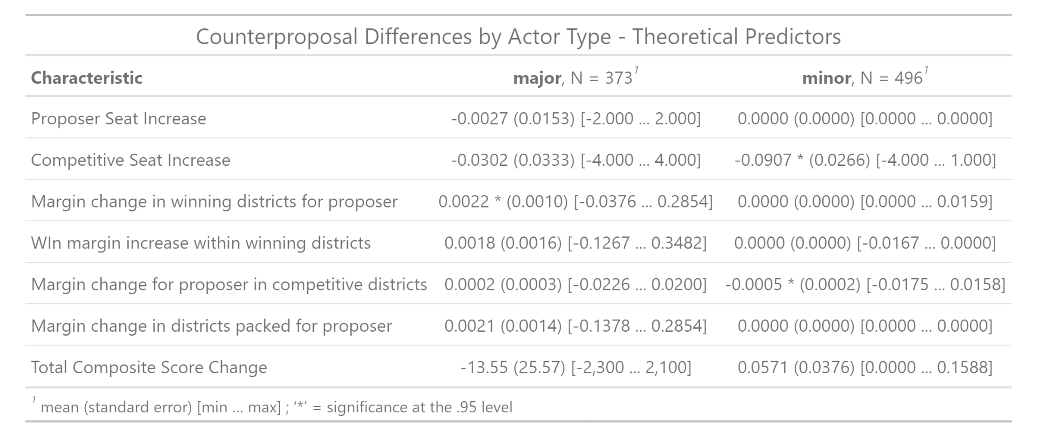
These results confirm that the overall impact that proposing parties have on seat differentials is marginal, which contradicts Premise 2.1. Surprisingly, they also show that the impact is also substantively marginal (although statistically significant for major and minor parties respectively) for both the winning or competitive margin differentials (which is evidence against Premise 4). This can be considered partial evidence showing that even when parties allegedly were looking to improve their chances of winning (or keeping) a seat in subsequent elections, the overall impact is minimal (the coefficients are very small for both major and minor parties). In the case of major parties, the range in all three dimensions includes negative values, which means that in some cases parties were actually receiving fewer votes, losing seats, or making districts slightly less competitive.
The third explanation ––side payoffs–– comprises both structural and ad-hoc side-benefits from redistricting. There are two potential structural side payoffs from a redistricting plan: compensating PR seats, and turnout effects, however the data supports neither: Although the country’s PR compensation mechanism has the potential to influence the behavior of smaller parties in some circumstance, we rule out this factor as an alternative explanation because larger parties’ actions are significantly constrained by the rules of the game. That is, even when parties suggested hundreds of alternative plans in both processes, they were not capable of substantially altering the distribution of seats. Consequently, the lack of variation in seat allocation could not have altered the share of seats obtained by parties and it is unlikely to explain their behavior.
Similarly, the hypothesis that turnout effects driver partisan line choice is not supported by the available data, since rates of national voter turnout in Mexico has varied little since 2000. For example, sección level turnout between the 2009 and 2015 midterm elections oscillates between 2.05 and 6.4 percent. The turnout difference between mid-term and concurrent presidential elections is constant and, on average, 14% higher. The largest historic turnout difference is due to Mexico´s voter registry complete renewal and voter identification issuance during the mid 1990s (INE 2017 and Moreno 2019).
Ad-hoc side payments cannot be entirely ruled out because it is impossible to know with certainty about all types of side payoffs. However, we find no circumstantial evidence showing that an alternative payoff is what is motivating engagement (e.g., obtaining a financial benefit); no public accusation of side-payments or ulterior goals have been made publicly; and no actor suggested the existence of side-payoffs in the private conversations comprising our fieldwork.
The fourth explanation -–limited party capacity–– proposes that parties believed that they had a substantial likelihood of gaining seats through redistricting, even if they did not. This hypothesis assumes that parties lack the capacity to correctly the results of their choices given the complex process, detailed rules, and uncertainty of the data.
Overall, we find evidence suggesting that there was within-game deviations from perfect rationality in some states. The case of PAN’s switching position between rounds in the 2017 process in Yucatán, the PT’s reversal or preferences in the state of Aguascalientes in 2013, and the substantial increase of higher-cost unanimous solutions in 2017, all suggest that parties are not engaging in the process exclusively with perfect understanding.
Despite a number of clear deviations from perfect play, there is no evidence showing that parties systematically sponsored plans that substantially undercut their electoral interests. The lack of variation in the predicted allocation of seats, as discussed in section 5.2, also implies that partisan engagement did not yield results that substantially decreased their expected seats. We also observe that the EMB has indirectly benefited by executing a technically complex process that is highly susceptible to becoming politicized while largely avoiding criticism by political parties.
Finally, the fifth explanation––building legitimacy through partisan inclusion–– proposes that parties have accepted the rules governing the redistricting game as long as they are still able to impose their preferences––by having the EMB accepting higher-scoring plans under unanimous agreement. Their presence and activism within the EMB have allowed them to directly become their own watchdogs while allowing the bureaucracy to indirectly benefit from the reputation developed around the implementation of a process that, so far, has not been challenged by political actors (Saldaña and Cervantes 2020). Further, while parties have historically acknowledged bureaucratic constraints ––e.g., selection of criteria, operationalization of the rules, and the use of algorithmic solutions–– limiting their capacity to alter results in their favor, they still “legitimize” the process by overseeing that no opponent obtains an intentional or administrative advantage.
Overall, this suggests that the parties and the bureaucracy have found a “higher benefit” associated with including parties in redistricting. By engaging in the process, parties seem to have adapted their strategies, learned how to “play the game,” and ensures that they are not being victims of administrative or partisan gerrymandering. In exchange, the bureaucracy has been able to successfully implement a technically complex process while minimizing politicization, facilitating consensus solutions, and legitimizing the process through partisan inclusion.

7. DISCUSSION
Our analysis shows that Mexico's institution of redistricting remains vitally important within the country’s mixed-member electoral system. If the institution of redistricting were eliminated and a purely proportional system was to be adopted, the distribution of seats would be substantially different (at least in the short term) ––advantaging smaller parties over their larger counterparts. In 2021, for instance, the majority tier offered the largest party (MORENA) a redistricting advantage of 56 seats. This finding contrasts with the initial rationale for adopting a proportional tier in Mexico during the late 1970s––which was used to curb PRI's majoritarian advantage. Today, the dominant party still gets a substantial bonus from the majoritarian single-member district tier compared to the expected seat return under a purely proportional system.
Although some credit MORENA's 2018 victory to redistricting, we find that it was not aided by how lines were drawn. In fact, MORENA was able to overcome the institutional majoritarian bias of redistricting in 2018, which had benefited the PRI during the 2015 midterm election because of the massive shift in voter loyalty from the PRI to MORENA. Further, only such an extreme shift in voting could have yielded a MORENA victory. Simulation analysis shows that under moderate voter swings ––of up to 50%–– the results would have been primarily an increase in PAN seats, with PRI remaining the majority party.
Contrary to expectations based on US political theory and Mexican media coverage, and despite the powerful influence of redistricting as an institution, we find that the specific choice of maps by the parties has had a marginal impact on electoral outcomes. Constrained by INE's institutional rules, the majority party, which had the greatest potential to benefit through redistricting maps, realized a gain of only five seats through the process (compared to not changing the lines at all), and had the potential to gain a maximum of fifteen seats (5% of the tier). While measurable, this potential advantage is far too small to be significant to national politics. From the administrative perspective, evidence suggests that duplicating the redistricting process in 2017 with slightly different criteria was redundant.
Our results indicate that INE's institutional rules had a substantial influence on the outcome. An analysis of the complete set of plans considered by the bureaucracy confirms that the variation in seat allocation given the proposed maps was highly constrained by how the INE interpreted the constitutional framework, operationalized the redistricting criteria, and implemented the process. Although it is difficult to isolate which specific component is driving the effect, we find that among the most influential rules affecting the stability of the outcomes are the preservation of municipal integrity, the adoption of geometric compactness in the optimization phase, as well as the acceptance of a considerably wide margin of population deviation (up to + / - 15%). Given the intra-state political demography and voter distribution, as the case of Mérida illustrates, INE’s implementation of these rules is determinative and leaves almost no space for alternatives that could substantially affect the outcomes.
Mexico’s closed-door interaction between parties and electoral bureaucrats, along with the ruling party’s claim of having a partial electoral arbiter in charge of redefining the electoral boundaries, are sufficient reasons to question if redistricting has led to neutral outcomes. While the institution of redistricting itself embeds a majoritarian bonus, we find parties did not gain a substantial advantage through manipulation of the process. As described above, the overall effect of districting lines was quite small, giving at most five seats to PRI in 2015. Thus, the translation of votes to seats was determined almost entirely by the pre-existing two-tiered constitutional framework and the INE's implementation of redistricting rules. Further, we found no evidence of partisan influence in INE's implementation of redistricting rules. On the contrary, the high levels of partisan engagement (e.g., parties submitted 522 and 463 alternative maps in 2013 and 2017, respectively), the increasing coordination of parties to unanimously endorse higher-scoring plans (criteria 8), and the absence of substantial petitions challenging rules and outcomes show how political actors comply with the process. The evidence clearly suggests that the growing criticisms against Mexico’s EMB independence are not justified.
Finally, we find that the dominant US theory of redistricting does not apply straightforwardly to Mexico. While US theory predicts that parties in control will gerrymander strategically to achieve near-optimal seat maximization, the observed outcomes and micro-behavior in Mexico are quite different. Not only was the overall advantage achieved by parties small, but analysis of micro-level party behavior also suggests that parties have maintained an interest in the process, adapted their behavior, acted strategically within a highly constrained process to gain marginal increases in district safety, and frequently appeared to lack the capacity to develop effective seat maximizing strategies within this constrained environment. These findings are particularly relevant to the U.S. audience because they show how the homogeneity of redistricting rules across states (i.e., compactness, sección base geography, population deviation margins, and municipal integrity) can substantially constrain the type of outcomes we observe in redistricting.

REFERENCES
Abramowitz, Alan I., Brad Alexander, and Matthew Gunning. 2006. “Incumbency, Redistricting, and the Decline of Competition in U.S. House Elections.” Journal of Politics. 68(1) 75-88.
Allen, Liz, Amy Brand, Jo Scott, Micah Altman and Marjorie Hlava. 2014. “Credit where credit is due.” Nature 508(7496):312–313.
Brady, David W. "Critical elections, congressional parties and clusters of policy changes." British Journal of Political Science 8, no. 1 (1978): 79-99.
______. 1988. Critical elections and congressional policy making. Vol. 1. Stanford University Press.
Brady, D., & Grofman, B. (1991). Sectional Differences in Partisan Bias and Electoral Responsiveness in US House Elections, 1850–1980. British Journal of Political Science, 21(2), 247-256.
Brady, David W., and Naomi B. Lynn. "Switched-seat congressional districts: Their effect on party voting and public policy." American Journal of Political Science (1973): 528-543.
Cain, Bruce E. 1985. "Assessing the partisan effects of redistricting." The American Political Science Review: 320-333.
______ . 2011. "Redistricting commissions: A better political buffer." Yale LJ 121 (2011): 1808.
Campbell, J. E. (2014). The presidential pulse of congressional elections. University Press of Kentucky.
Colomer, Josep. 2018. “Party System Effects on Electoral Systems.” In Erik S. Herron, Robert J. Pekkanen, and Matthew S. Shugart. The Oxford Handbook of Electoral Systems. Oxford: Oxford University Press.
Cox, Gary W. and Jonathan N. Katz. 2002. Elbridge Gerry’s Salamander: The Electoral Consequences of the Reapportionment Revolution. New York: Cambridge University Press.
Cox, Gary. 1997. Making Votes Count: Strategic Coordination in the World’s Electoral System. Cambridge: Cambridge University Press.
Daxecker, Ursula. "Unequal votes, unequal violence: Malapportionment and election violence in India." Journal of peace research 57, no. 1 (2020): 156-170.
De Paola, M., & Scoppa, V. (2014). The impact of closeness on electoral participation exploiting the Italian double ballot system. Public choice, 160(3), 467-479
Engstrom, Erik J. 2006. “Stacking the states, stacking the House: The partisan consequences of congressional redistricting in the 19th century.” American Political Science Review 100(3):419–427.
Erikson, Robert S. 1972. “Malapportionment, gerrymandering, and party fortunes in congressional elections.” The American Political Science Review 66(4):1234–1245.
Fuentes, Victor. 2023. “Sepulta Suprema Corte Plan B electoral de AMLO.” Mexico City: Reforma Newspaper. Published on May 9. Accessed online: https://www.reforma.com/sepulta-suprema-corte-plan-b-electoral-de-amlo/ar2601236?v=10
Gelman, A., & King, G. (1994). Enhancing democracy through legislative redistricting. American Political Science Review, 541-559.
Geys, Benny (2006), "Explaining Voter Turnout: a Review of Aggregate-Level Research", Electoral Studies, núm. 25, pp. 637
Handley, Lisa and Bernard Grofman. 2008. Redistricting in Comparative Perspective. Oxford: Oxford University Press.
Heberlig, E. S., & Larson, B. A. (2012). Congressional parties, institutional ambition, and the financing of majority control. University of Michigan Press.
IFE. 2004. “Acuerdo del Consejo General del Instituto Federal Electoral por el que se aprueban los criterios y consideraciones operativas que se utilizarán en la formulación de los proyectos de división del territorio nacional en trescientos distritos electorales federales uninominales, así como la creación del Comité Técnico para el seguimiento y evaluación de los trabajos de distritación.” Acuerdo del Consejo General del IFE CG104/2004.
______. 2005. “Distritación 2004–2005: Camino para la democracia.” Registro Federal de Electores. Primera edición.
______. 2012. Distritación 2012-2013. Ruta Crítica. Registro Federal de Electores. México: Instituto Federal Electoral.
______. 2013a. “Acuerdo del Consejo General del IFE para aprobar los criterios que se usarán en la creación de 300 distritos federales uninominales en que se divide el territorio nacional.” CG50/2013 http://www.ine.mx/docs/IFE-v2/DERFE/ DERFE-CNV/2013/Redistritacion/CGe60213ap4.pdf.
______. 2013b. “Acuerdo del Consejo General por el que se aprueba la propuesta de criterios que se utilizarán para formular los estudios y proyectos para la división del territorio en 300 distritos electorales uninominales federales, a propuesta de la Junta General Ejecutiva.” Acuerdo del Consejo General del IFE CG50/2014.
Indridason, Indridi. 2008. "Competition and Turnout: the Majority Run-Off as a Natural Experiment", Electoral Studies, núm. 27, pp. 699
INE. 2015. “Modelo Matemático y Algoritmos.” Registro Federal de Electores.
______. 2017. Estudio Comparativo sobre la Participación Ciudadana en las Elecciones Federales de 2009, 2012 y 2015. Ciudad de México, Dirección Ejecutiva de Capacitación Electoral y Educación Cívica. Instituto Nacional Electoral.
______. 2019. Memoria de la Distritación Electoral Nacional 2014-2017. México: Instituto Nacional Electoral.
Jackman, S. (1994). Measuring Electoral Bias: Australia, 1949–93. British Journal of Political Science, 24(3), 319-357.
Kasara, K. (2014). Electoral geography and conflict: Examining the redistricting through violence in Kenya. Columbia University.
Lublin, David. 1999. “Racial Redistricting and African-American Representation: A Critique of ‘Do Majority-Minority Districts Maximize Substance Black Representation in Congress?’” American Political Science Review, 93:1.
Lujambio, A., 2000. El poder compartido: un ensayo sobre la democratización mexicana. México: Océano
Manetto, Francesco. 2021. “López Obrador escala su campaña contra el INE y lo acusa de ‘atentado a la democracia.’” El País. April 14, 2021. Available online: https://elpais.com/mexico/2021-04-14/lopez-obrador-escala-su-campana-contra-el-ine-y-lo-acusa-de-atentar-contra-la-democracia.html?event_log=oklogin.
Magar, E. (2018). Recent Mexican Election Vote Returns [Computer software]. https://github.com/emagar/elecRetrns
Magar, Eric, Alejandro Trelles, Micah Altman and Michael P. McDonald. 2015. “Measuring malapportionment, gerrymander, and turnout effects in multi-party systems.” Type- script, ITAM.
Martínez i Coma, F. and Lago, I., 2018. Gerrymandering in comparative perspective. Party Politics, 24(2), pp.99-104.
Mayhew, David R. 1974. Congress: The Electoral Connection. New Haven: Yale University Press.
McDonald, Michael P. 2004. “A comparative analysis of redistricting institutions in the United States, 2001–02.” State Politics and Policy Quarterly 4(4):371–95.
______. 2008. “United States Redistricting: A Comparative Look at the 50 States.” In Lisa Handley and Bernard Grofman (Eds). 2008. Redistricting in Comparative Perspective. Oxford: Oxford University Press.
Meng, Anne, and Brian Palmer-Rubin. "Gerrymandering opposition: minority-concentrated districts and electoral competition in Mexico." Studies in Comparative International Development 52, no. 1 (2017): 64-86.
Molinar Horcasitas, Juan; Weldon Uitti, Jeffrey A. (2001) "Reforming Electoral Systems in Mexico". En Shugart, Matthew Soberg; Wattenberg, Martin P. (eds.). Mixed-Member Electoral Systems : The Best of Both Worlds? New York, N. Y.: Oxford University Press.
Moreno, Alejandro. 2019. "Introducción: landslide 2018". En Moreno, Alejandro ; Uribe Coughlan, Alexandra ; Wals, Sergio C. (coords.). El viraje electoral : opinión pública y voto en la elecciones de 2018 en México. Ciudad de México: Cámara de Diputados, LXIV Legislatura, Centro de Estudios Sociales y de Opinión Pública, 2019, p.25-53. ISBN 9786078621330.
Morgenstern, S. (2003). Patterns of legislative politics: roll-call voting in Latin America and the United States. Cambridge University Press.
Morgenstern, Scott, and Peter Siavelis, eds.2008. Pathways to power: political recruitment and candidate selection in Latin America. Pennsylvania State University Press.
Murayama, Ciro. 2020. “Sobrerepresetación.” Mexico City. Periódico Reforma.
Olmeda, Juan Cruz and Lisandro Martín Devoto (2019). ¿Together or Apart? Assessing the Success of Electoral Coalitions at the Subnational Level in Mexico. Revista Mexicana de Ciencias Políticas y Sociales. 64 (235).
Owen, Guillermo, and Bernard Grofman. 1988. "Optimal partisan gerrymandering." Political Geography Quarterly 7, no. 1: 5-22.
Raphael, Ricardo. 2022. “La reforma electoral de Morena busca una transformación política completa de México.” The Washington Post. October 19, 2022. Available online:https://www.washingtonpost.com/es/post-opinion/2022/10/19/reforma-electoral-2022-amlo-desaparecer-ine-morena/.
Reyes, Javier Martín y María Marván Laborde, Coord. 2023. Radiografía del Plan B: La Reforma Electoral de 2023 a Examen. Instituto de Investigaciones Jurídicas. Universidad Nacional Autónoma de México. Primera Edición, 23 de febrero de 2023.
Rogowski, Jon C. "Presidential influence in an era of congressional dominance." The American Political Science Review 110, no. 2 (2016): 325.
Rossiter, D.J., R.J. Johnston and C.J. Pattie. 1997a. “Estimating the Partisan Impact of Redistricting in Great Britain.” British Journal of Political Science 27(2):319–31.
______. 1997b. Redistricting and Electoral Bias in Great Britain. British Journal of Political Science, 27(3), 453-472.
Saldaña, José Roberto Ruiz, and Pablo Alfonso Cervantes González. "Redistritación federal en México: una revisión de sentencias en preparación de la siguiente." Revista Justicia Electoral 1, no. 26 (2020): 249-303
Sheridan, Mary Beth. 2023. López Obrador overhauls Mexican electoral system, sparking protests. The Washington Post. Published on December 15, 2022. Available online: https://www.washingtonpost.com/world/2022/12/15/lopez-obrador-electoral-reform-mexico/
Shotts, Kenneth W. 2003. “Does Racial Redistricting Cause Conservative Policy Outcomes? Policy Preferences of Southern Representatives in the 1980s and 1990s (in Research Notes)” Journal of Politics, 65(1): 216-226.
Shugart, Matthew S. and Rein Taagepera. 2018. Electoral System Effects on Party Systems. In Herron, Pekkanen and Shugart. The Oxford Handbook of Electoral Systems. Oxford: Oxford University Press.
Sonnleitner, Willibald (2001), Los Indígenas y la Democratización Electoral: Una Década de Cambio Político entre los Tzotziles y Tzeltales de Los Altos de Chiapas (1988-2000). México: El Colegio de México/Instituto Federal.
______ (2013), La Representación Legislativa de los Indígenas en México: De la Representatividad Descriptiva a una Representación de Mejor Calidad. México: Tribunal Electoral del Poder Judicial de la Federación. http://portal.te.gob.mx/sites/default/files/32_representacion.pdf [Accessed on: June 25, 2015].
______. 2017. Redistricting, Transparency, and Political Representation of Minority Groups in Mexico: 1990-2017. In Luis Carlos Ugalde y Saíd Hernández Quintana, Strengths and Weaknesses of the Mexican Electoral System, 1990-2017. Federal and Local Perspectives. Mexico City: Electoral Tribunal (TEPJF).
Suprema Corte de Justicia de la Nación. “Comunicado de Prensa: La Corte declara la invalidez de la primera parte del paquete de reformas político-electorales 2022-2023, por violaciones al procedimiento legislativo.” No. 161. Ciudad de México, 8 de Mayo de 2023. Available: https://www.internet2.scjn.gob.mx/red2/comunicados/noticia.asp?id=7347
Trelles, Alejandro and Diego Martínez. 2012. “Fronteras electorales: lecciones de la redistritación en México para California.” Política y Gobierno 19(2):199–241.
______. 2007. Fronteras electorales: aportaciones del modelo de redistritación mexicano al estado de California Ba. thesis ITAM.
Trelles, Alejandro, Micah Altman, Eric Magar and Michael P. McDonald. 2016. “Datos abiertos, representación política y redistritación en México.” CIDE: Política y Gobierno.
______. 2023. “No Accountability without Transparency and Consistency: Evaluating Mexico’s Redistricting-by-Formula.” Election Law Journal: Rules, Politics, and Policy, 22:1, 80-99.
Tufte, Edward. 1973. “The Relationship Between Votes and Seats in Two-Party Systems.” American Political Science Review 67: 540-54.
Weldon, Uitti, Jeffrey A, 2001. The consequences of Mexico’s mixed-member electoral system, 1988-1997. In Shugart, M. and Wattenberg, M.P. eds., 2001. Mixed-member electoral systems: The best of both worlds?. pp.447-476 Oxford: Oxford University Press.
______. (2005). "Mexico: Democratization Through Electoral Reform". En Reynolds, Andrew; Reilly, Ben; Ellis, Andrew (comps.). Electoral System Design: The New International IDEA Handbook. Stockholm, Sweden: International Institute for Democracy and Electoral Assistance.
Wong, S. (2019). Gerrymandering in Electoral Autocracies: Evidence from Hong Kong. British Journal of Political Science, 49(2), 579-610.
Zazueta, I.M.S. and Cortez, W.W., 2014. Determinantes de la participación electoral en México. Estudios sociológicos, pp.323-353

ONLINE APPENDICES

Appendix 1. Contextualizing Redistricting in Mexico

1.1 The evolution of electoral boundary delimitation in Mexico
Electoral technocrats and political parties have been captivated by redistricting since Mexico held their first competitive elections in the 1990s. Every cycle, the EMB invested significant bureaucratic, technological, and administrative resources to execute redistricting (INE 2019). The 2013 and 2017 redistricting cycles, for instance, took the EMB 24 and 38 months to complete, respectively (IFE 2012 and INE 2019). According to the EMB’s registry of voters, the financial cost for the 2013 process was approximately 1.5 million dollars. It involved the multilateral cooperation of external institutions – e.g., the census bureau (INEGI) and the National Commission for the Development of Indigenous Communities (CDI), and a multi-stage effort within the electoral bureaucracy – e.g., the EMB’s cartography department (CD), the IT department (UNICOM), the national and local surveillance commissions (CNE and CLVs), the registry of voters (DERFE), the technical committee (TC), the general council (JGE), and executive board (Consejo General).
Mexico’s political parties have also been captivated by the redistricting process. First, Mexico’s transition from a purely majoritarian system to a mixed-member electoral system (MMES) in the late 1970s gradually increased the presence of opposition parties in the legislature through proportional representation (PR) seats (Weldon 2005). Along with the local alternation in power in several northern and central states during the 1908s and1990s, the 300 single-member majority districts (SMD) increasingly became more competitive (Lujambio 2000). The ruling party, which used to win over 90% of the seats during the 1960s, 1970s, and the early 1980s, lost its majoritarian status in the mid-1990s.
After the inception of MORENA in 2014 and its arrival to power in 2018, the PRI became a minority party in the legislature obtaining less than 10% of the SMD seats. While proportionality has historically allowed minority parties to access legislative representation, the SMD tier has systematically overcompensated parties that are able to secure a larger share of votes across states and has been maintained to prevent extreme fractionalization of the party system (Cox 1997, Lujambio 2000, and Weldon 2005). The increasing competitiveness in the SMD tier, however, has created incentives for major parties to pay close attention to when and how district lines are being drawn.
Opposition parties – i.e., PAN and PRD, for instance, raised concerns about malapportionment in the 1980s and 1990s. Mexico’s population increased 21% in the decade, from roughly 67 million in 1980 to 84 million in 1990. Internal migration and demographic shifts across states made the apportionment phase of redistricting particularly relevant for opposition parties whose electoral strongholds are found in central and northern states, and where demographic shifts were significantly larger than in its southern counterparts (Michel and Ribardière 2017, Sobrino 2018, and Pérez-Campuzano et al., 2018).
The number of districts assigned to Mexico City (CDMX) and the State of Mexico (EdoMex), for instance, experienced the largest population shifts. The former went from having 30 districts in 1996 to 27 in 2004, and 24 in 2017. EdoMex, which is the country’s largest state, went from having 36 districts to 40, and then to 41, respectively. This state had a significant population imbalance within its congressional districts prior to the 2013 and 2017 redistricting cycles (using 2004 districts based on the 2000 census results). Approximately one-fourth of its districts were beyond the +/- 15 % maximum deviation allowed by statutes.
Population shifts across states have forced parties to accept reapportionment as a loss for some and a gain for others. Mexico City, for instance, became a stronghold of the left-wing PRD in the mid-1990s, while EdoMex remained a PRI stronghold until recently. The parties have come to recognize redistricting as a necessary and effective mechanism for eliminating district-level asymmetries and ensuring the “one person-one vote principle” across the country’s 300 SMDs.
Mexico's electoral management system was designed as a consequence of a generalized sentiment of mistrust towards the ruling party due to the flagrant interference in elections (Scott 1964, Johnson 1978, Schedler 2002, Levitsky and Way 2010, Woldenberg 2012, Langston 2017, and Cantú 2019). Among many other administrative procedures (i.e., voter registration or mechanisms to guarantee the secrecy of voting), parties considered redistricting a key policy for guaranteeing a “leveled” electoral playing field (Lujambio and Vives 2008). Prior to 1996, for instance, redistricting was implemented by the Comisión Federal Electoral (CFE), a board presided by Mexico’s Minister of the Interior (SEGOB) and de facto controlled by the executive branch. Consequently, the process was viewed by opposition parties as neither transparent nor neutral (Trelles and Martínez 2007).
The 1996 redistricting process occurred the same year the EMB became fully independent from the executive branch. The process also took place in the preamble of the 1997 midterm election where the ruling party – the Partido Revolucionario Institutional or PRI – lost for the first time its majoritarian status in the legislature. A few years later, in 2000, the country culminated its democratic transition with its first peaceful alternation in power (Lujambio and Vives 2008). This increasingly competitive environment incentivized the parties to function as “watchdogs” that would legitimize the process by guaranteeing the neutrality and transparency of key administrative decisions (Estévez et al., 2008).
In order to prevent partisan gerrymandering, the EMB included in 2004 a “geometric compactness” restriction that ranked second in order of importance after the “equal population” criteria (IFE 2004, Trelles and Martínez 2007). In the preamble of the 2014 electoral reform, opposition parties demanded that the responsibility to renew the electoral geography across the 32 states was centralized in a national-level bureaucracy that would apply the same rules and criteria across states in order to minimize the political interference of state-level actors.
As a way to ensure transparency and neutrality in redistricting, a national and thirty-two local oversight commissions (CNV and CLVs, respectively) have served as the main internal consultation mechanism allowing parties to closely monitor, audit, and participate in all stages of the process. Since 1996, all parties have engaged in the process and have formulated suggestions to algorithmically produced maps through these national and local representations. In 2013, for instance, parties proposed 522 alternative plans and in 2017 they suggested 463 maps, which reveals the high levels of interest parties have in the process.
In the last three decades, there have been relevant technological, administrative, and socio-political changes affecting the ways in which parties engage in the process (Trelles 2017). During the 1996 process, for example, the EMB used a desktop machine in the main headquarters to run a heuristic optimization algorithm and only parties represented at the CNV were informed through printed maps how districts had changed. In contrast, during the most recent 2017 redistricting round the EMB was able to share online algorithmically produced plans with all parties. This software also had map-editing capabilities allowing parties to visualize maps and compare their own plans – and scoring functions – with those submitted by other parties.
The administrative-level rules that have been used to renew electoral boundaries have also changed over time. While in 1996 it was hard to compare maps using quantitative metrics, IFE´s Cartography Department developed a software interface for the 2004 process that allowed the technical committee (TC) to compare and evaluate plans based on a quantitative parameter allowing them to quantify each of the restrictions included in the cost function. In the 2017 cycle, the EMB decided to introduce “criterion 8,” a rule allowing parties to endorse a map with a higher associated cost as long as no party opposed that alternative. This new rule has incentivized parties to compromise and build consensus around plans that are preferred to the algorithmic solution despite having a higher cost.
The changing socio-political environment has also had implications for how parties formulate counter-proposals. The rise of independent voters over time has made it harder for parties to cultivate stable regional strongholds and, consequently, parties are less certain of their long-term partisan adepts at the district level (Moreno 2018). Additionally, violence is rapidly transforming the country’s political landscape. In 2004, for instance, drug cartels’ territorial disputes were not a significant factor that parties considered when formulating counter-proposals. According to INE’s cartography director, the spike of violence in certain municipalities during Calderón and Peña Nieto's administration, however, has affected the rationale used by parties and the EMB to create scenarios both in the 2013 and 2017 processes.
In sum, the level of awareness and the number of actors participating in the process has significantly increased over the years. Redistricting has evolved from a process where only a few electoral technocrats rebalanced the population across districts, to a more inclusive process that has gradually adopted different mechanisms to include the opinion of both local and national parties (respectively represented in the CNV and CLVs), as well as of minority communities – e.g., indigenous majority districts in 2004 and public consultations in 2017. The development of a computer-based capacity to process optimization, the emergence of online mapping technology, and the electoral tribunal’s ruling on citizens’ rights and representation have gradually contributed to making redistricting a more inclusive process (Trelles 2017).

1.2 Party interaction by stage and level

Following the logic of revealed preference analysis (RPA), a method built on the Weak Axiom of Revealed Preference (WARP) used to infer preferences from a rational actor (Samuelson 1948, Varian 2006), we assume that if plan p₁ is chosen by a party from a set of plans P = {p_{1,} p_{2,}…p_{n}}, then the plan must be preferred over all other plans in the set. We also assume that parties prefer their counter-proposal to those of all other parties during that round––even if these proposals were technically simultaneous. In other words, we assume that parties can analyze potential plans to the extent other parties are not better able to determine their own interests.
The high levels of partisan engagement––lower level (actions)––are prima facie evidence that parties are interested in redistricting. Table 1.2.1 depicts the total number of plans proposed by parties and the variation observed when looking at the patterns of play during the 2013 and 2017 cycles ( M_{2,p} and M_{3,p}). For example, if parties would have proposed a plan for every instance where they were entitled to do so (e.g., at two different levels – CNV or CLV; in each of the two rounds; and in each one of the 32 states), the total universe of observed plans would have been 896 partisan plans in 2013 (M_{2,p} and M_{3,p} = 448 per round) and 1,152 plans in 2017 (M_{2,p} and M_{3,p} = 576 per round). Instead, the data reveals that parties engaged selectively ––they did not suggest a plan at every level, stage, or round. In 2013, for instance, parties proposed a total of 522 alternative plans, which represent approximately 58.25% out of the universe of 896 possible plans. In contrast, parties were less active in 2017 than in 2013, formulating a total of 463 counter-proposals during the 2017 redistricting process, which represents 40.2% out of the universe of 1,152 possible plans.
Table 1.2.1 Plans formulated by parties in the 2013 and 2017 redistricting processes
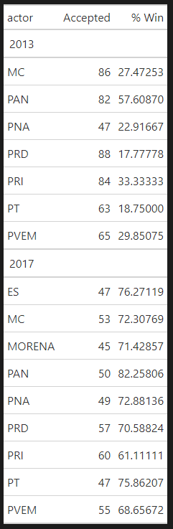
Note: The success rate in parenthesis reports the share of plans that were adopted by the TC in the first and second rounds of partisan interaction. Prepared by authors with information from the National Electoral Institute.

While the traditional three large parties (PAN, PRI, PRD) formulated more than 80 plans in 2013, smaller parties (PT, PVEM, PNA), except MC, formulated approximately 30% fewer plans that same year. In contrast, the variation in the total number of plans suggested by each party was significantly less in 2017. The PRI, for instance, was the most active party formulating 60 plans, while MORENA was the least active one and formulated 45. That is, there was a difference of only 15 plans between the most and least active party in 2017 – versus a difference of 41 in 2013.
We also observe a change in how parties engage in the process at the national and local level, which we interpret as a possible adjustment or learning process in the parties’ internal strategy. For example, parties shifted from adopting a mixed-engagement pattern in 2013 to a highly decentralized scheme in 2017. In 2013, parties formulated at the state level – through parties represented at the 32 CLVs – a very similar number of plans to the one suggested by the representatives represented at the national level, the CNV (274 vs 248, respectively). In contrast, national-level parties withdrew from the redistricting scene in 2017. They went from formulating 248 plans through the CNV in 2013 to only 16 in 2017. Local parties, however, almost doubled the number of proposed plans (from 274 in 2013 to 437 in 2017).
The varying level of effectiveness (the number of plans that were actually adopted by the TC) is also intriguing. Interestingly, the success rates were quite different between 2013 and 2017. While in 2013, the right-wing PAN was the most effective party in formulating winning scenarios (with a 57% success rate), the rest of the larger (PRI and PRD) and smaller parties (PT, PVEM, MC, PNA, MORENA, and ES) became significantly more effective in the next redistricting cycle. The PT, a relatively small left-wing party, formulated 12 winning scenarios out of 63 in 2013 (18% success rate). In 2017, however, the same party-endorsed 36 winning alternatives over a total of 47 plans proposed (75% success rate). Similarly, the left-wing PRD formulated only 15 winning scenarios out of 88 alternatives in 2013 (17% success rate). In contrast, they became significantly more effective and formulated 39 successful plans out of 57 in 2017 (70% success rate). Overall, these results show parties were more active in 2013 compared to 2017 (formulating 522 vs 463 plans, respectively) but also significantly less effective in getting their preferences adopted by the TC (average success rate of 29% vs. 72%, respectively).
Table 1.2.2 depicts the total number of partisan plans proposed by parties at the stage level (M_{2,p} and M_{3,p}) during the 2013 and 2017 processes. These results show the varying levels of effectiveness when parties formulated alternative plans (numerators represent the number of plans that were adopted by the TC). Interestingly, the success rates were quite different between 2013 and 2017. While in 2013 the right-wing PAN was the most effective party in formulating winning scenarios, the rest of the larger (PRI and PRD) and smaller parties (PT, PVEM, MC, PNA, MORENA, and ES) became significantly more effective in the next redistricting cycle. The PT, which is a relatively small left-wing party, formulated 6 winning scenarios out of 63 in 2013.
In 2017, however, the same party endorsed 30 winning alternatives over a total of 47 plans proposed. Similarly, the left-wing PRD formulated only 15 winning scenarios, out of a total of 95 alternatives, in 2013. In contrast, they became significantly more effective and formulated 31 successful plans out of 57 in 2017. Overall, these results show parties were more active in 2013 compared to 2017, but also significantly less effective.

Table 1.2.2 Partisan counter proposals formulated by stage in the 2013 and 2017 redistricting processes

2013 |  |  |  |  | 2017
Party | 1st Round (λ_{1,13}) | 2nd Round (λ_{2,13}) | Total  (λ_{1+2,13}) |  | 1st Round (λ_{1,17}) | 2nd Round (λ_{2,17}) | Total  (λ_{1+2,17})
PAN | 19/42 | 21/40 | 40/82 |  | 13/20 | 23/30 | 36/50
PRI | 2/28 | 14/56 | 16/84 |  | 8/27 | 20/33 | 28/60
PRD | 5/48 | 10/47 | 15/95 |  | 12/22 | 19/35 | 31/57
PT | 2/32 | 4/31 | 6/63 |  | 6/17 | 24/30 | 30/47
PVEM | 1/20 | 10/45 | 11/65 |  | 9/22 | 21/33 | 30/55
MC | 1/38 | 8/48 | 9/86 |  | 10/22 | 21/31 | 31/53
PNA | 1/19 | 7/28 | 8/47 |  | 9/20 | 20/29 | 29/49
MOR | - | - | - |  | 8/20 | 16/25 | 24/45
ES | - | - | - |  | 9/19 | 21/28 | 30/47
Total | 31/227 | 74/295 | 105/522 |  | 84/189 | 194/274 | 278/463

Note: Denominator reports the number of counter-proposals made, numerator how many were adopted. Prepared by authors with information from the Federal Electoral Institute.

We also found significant variation in party behavior between the national and local level. Table 1.2.3 depicts the partisan plans aggregated by level (national vs local). The ratio in each cell represents the plans accepted in relation to the total number of plans submitted by each party. These differences confirm that political parties have learned to play the redistricting game and that state level parties – represented across the 32 CLVs – have become more effective players over time.

Table 1.2.2 Partisan counter proposals formulated by level in the 2013 and 2017 redistricting processes

2013 |  |  |  |  | 2017
Party | National (CNV) | Local (CLVs) | Total |  | National (CNV) | Local  (CLVs) | Total
PAN | 34/46 | 6/36 | 40/82 |  | 2/3 | 24/47 | 26/50
PRI | 8/30 | 8/54 | 16/84 |  | 1/4 | 27/56 | 28/60
PRD | 8/56 | 7/39 | 15/95 |  | 5/14 | 26/43 | 31/57
PT | 4/27 | 2/36 | 6/63 |  | 2/2 | 28/45 | 30/47
PVEM | 7/28 | 4/37 | 11/65 |  | 1/2 | 29/53 | 30/55
MC | 7/49 | 2/37 | 9/86 |  | 0/1 | 31/52 | 31/53
PNA | 4/12 | 4/35 | 8/47 |  | 0/0 | 29/49 | 29/49
MOR | - | - | - |  | 0/0 | 24/45 | 24/45
ES | - | - | - |  | 0/0 | 30/47 | 30/47
Total | 72/248 | 33//274 | 105/522 |  | 11/16 | 248/437 | 259/463

Note: Denominator reports the number of counter-proposals made, numerator how many were adopted. Prepared by authors with information from the Federal Electoral Institute.

In 2013, for instance, the total number of partisan plans formulated at the state level – through parties represented at the 32 CLVs – was very similar to the number of plans suggested by parties at the national level (274 vs 248, respectively). That same year, national level parties represented at the CNV, compared to their local counterparts, were twice as effective in getting their plans accepted (72 vs 33, respectively). Surprisingly, this pattern dramatically changed in the 2017 round. National level parties almost disappeared from the redistricting scene (from 248 in 2013 to only 16 plans in 2017) and local parties almost doubled the number of proposed plans (from 274 in 2013 to 437 in 2017).
Out of the total universe of counter-proposals that could have been made in 2013 (more than one thousand), for instance, political parties decided to put forward approximately five hundred alternative maps. This reveals that parties went through an internal strategic decision-making process, that they opted out in some cases because they preferred the status quo, or manifested their interest to support an alternative plan to be considered by the TC. In the 2004 process, it was clear that local and national level parties faced coordination problems. Before the EMB developed an online platform to discuss counter proposals (pre-2013), the discussions being held by technical experts in IFE’s headquarters in Mexico City, did not always consider key socioeconomic or geographical accidents at the local level.
One of the most emblematic cases was the adoption of a map in the northern state of Sonora, where one of the districts (district number 4 based on Guaymas) ran northeast from the Sea of Cortés all the way to Bavispe, a border town with the state of Chihuahua. It includes 39, out of the state’s 72 municipalities, that are socioeconomically diverse and, more importantly, the district is split in half by Sierra Madre Occidental (a mountain range with an elevation of more than 8,000 feet). This also reveals that local and national parties, despite sharing the same party label (e.g., the party members of one party like PRI represented at IFE vs the party members of that same party in the northern state of Sonora), might face coordination and information asymmetry problems and have a different perspective of political geography, competitiveness, campaigning logistics.

Appendix 2. Competitiveness and state level analysis

2.1 Competitiveness as an alternative metric to seat allocation

We analyze if there are any “winners and losers” based on the number of competitive seats between the 2013 and 2017 redistricting cycles. Table 2.1.2 compares the three different alternatives that were considered by the EMB (algorithmic, best, and winning plans) based on the 2015 and 2018 turnout. Results show that the 2017 redistricting cycle produced slightly less competitive seats based on both the 2015 and 2018 turnout. Based on the 2015 turnout, for instance, the algorithmic solution in 2013 produced 39 competitive seats, while the 2017 algorithm produced 8 less competitive districts (with the 2018 turnout the difference was of only one district). When comparing the number of competitive seats among the universe of winning plans based on the 2015 turnout, the 2013 cycle produced 33 competitive districts while the 2017 redistricting produced only 26. With the 2018 turnout, there were 22 competitive districts in the 2013 cycle and only 17 with the 2017 plans.

Table 2.1.1: Competitive seats based on the 2013 and 2017 redistricting plans

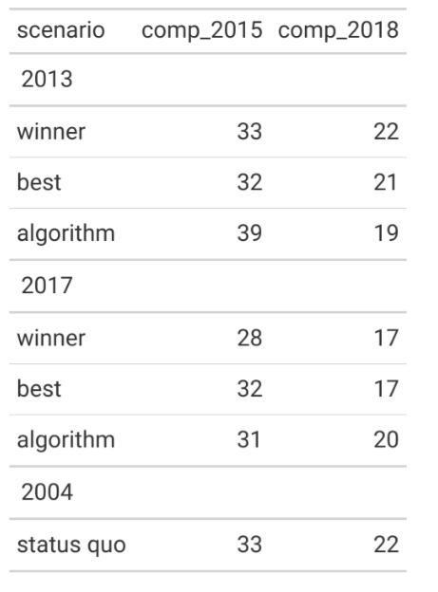

Table 2.1.2 examines the sensitivity of the competitiveness results to variations in the threshold used to classify sensitive districts. There is no substantive change. While the number of districts identified as competitive change substantially when changing the threshold from 2% to 4% -- the variation in the total number across scenarios plans remains negligible under the 2015 election scenario, and quite small under the 2018 scenario. Further using an 8% yields no differences in predictions.

Table 2.1.2: Competitive seats based on the 2013 and 2017 redistricting plans. Robustness check.

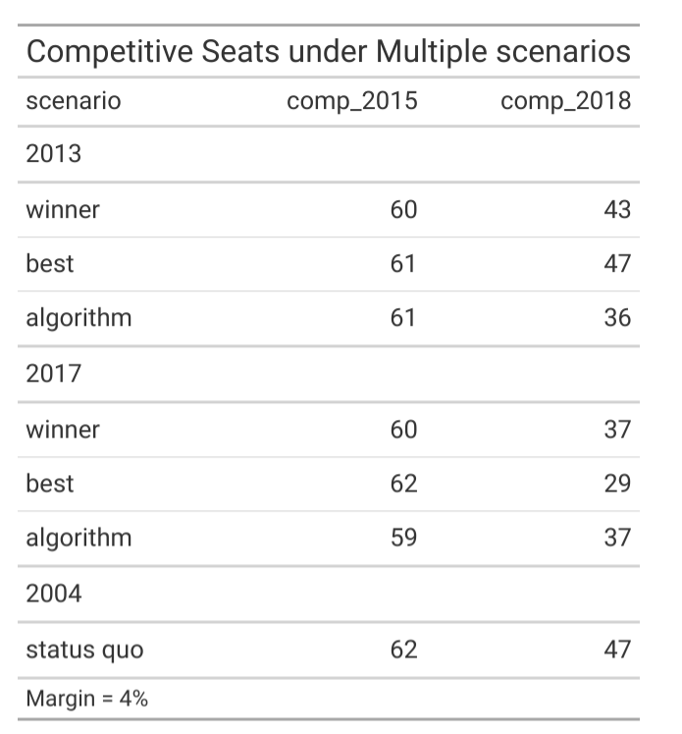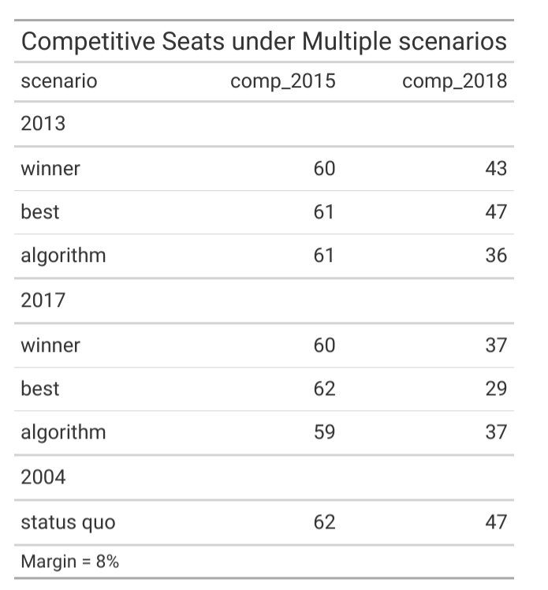
Which parties sponsored plans with competitive districts? Table 2.1.3 reveals the distribution of competitive seats endorsed by each party –or group of parties (coalition and unanimity). While the number of winning plans with competitive seats endorsed by a coalition of parties stayed very close across processes, the number of winning and best competitive plans endorsed by the right-wing PAN almost disappeared in 2017 (from 18 and 11 to 0 and 2, based on the 2015 and 2018 turnout respectively). The PRD significantly increased the number of best-scoring competitive alternatives in 2017 (9 and 4), but only sponsored a single plan with a winning competitive district in 2017 based on the 2015 turnout. Lastly, table 6 shows that the number of competitive seats in winning plans that were sponsored by parties unanimously more than doubled in 2017 (from 3 and 3 in 2013 to 9 and 7 in 2017).

Table 2.1.3: Competitive seats based on the 2013 and 2017 redistricting plans among parties
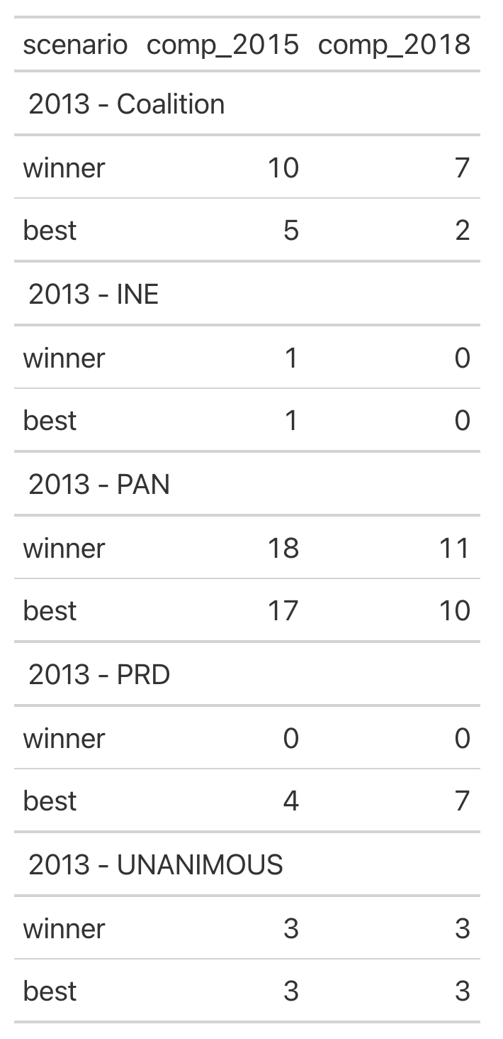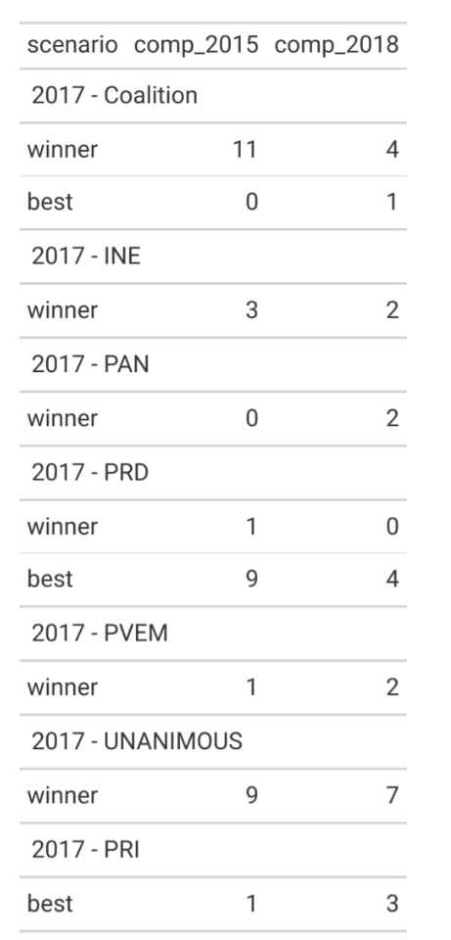

Overall, the analysis of competitiveness shows that the 2017 cycle was more restrictive in terms of having individual parties (i.e., the PAN) pushing forward an agenda with a slightly higher number of competitive seats (18 and 11 in 2013, based on the 2015 and 2018 turnout respectively, vs 0 and 2 in 2017). It also shows that consensus solutions around competitive seats were more common in 2017 than in 2013. This last finding is probably explained by the adoption of the unanimity rule (criterion 8) for the 2017 cycle.

2.2 Political implications in the State of Mexico (EdoMex) and Guanajuato
We analyze seat differentials in two cases where we would expect changes in the algorithm and partisan interaction would be more pronounced given that they can be considered medium to large states in terms of the total number of districts in each state. On one hand, we selected the most populated state in the country –El Estado de México (EdoMex) – and, on the other, we picked a mid-size state, Guanajuato, with 40 and 15 districts, respectively. We also compare district plans based on the level of competitiveness to diagnose the overall impact of redistricting using an alternative metric.
In order to analyze seat differences at the state level, table 2.2.1 depicts the result for Mexico’s most populated state, the Edomex, which was assigned 40 districts in the 2004 redistricting cycle, and 41 in 2013 and 2017. Given its demographic density and its growth over time, this is one of the states where changes in the electoral geography should have a more pronounced effect on the distribution of seats among parties. This table compares the seat distribution among parties based on a hypothetical (academic) plan favoring the PRI, the two scenarios considered by the EMB (winning plan and algorithmic solution), and the previous plan approved in 2004 (status quo).

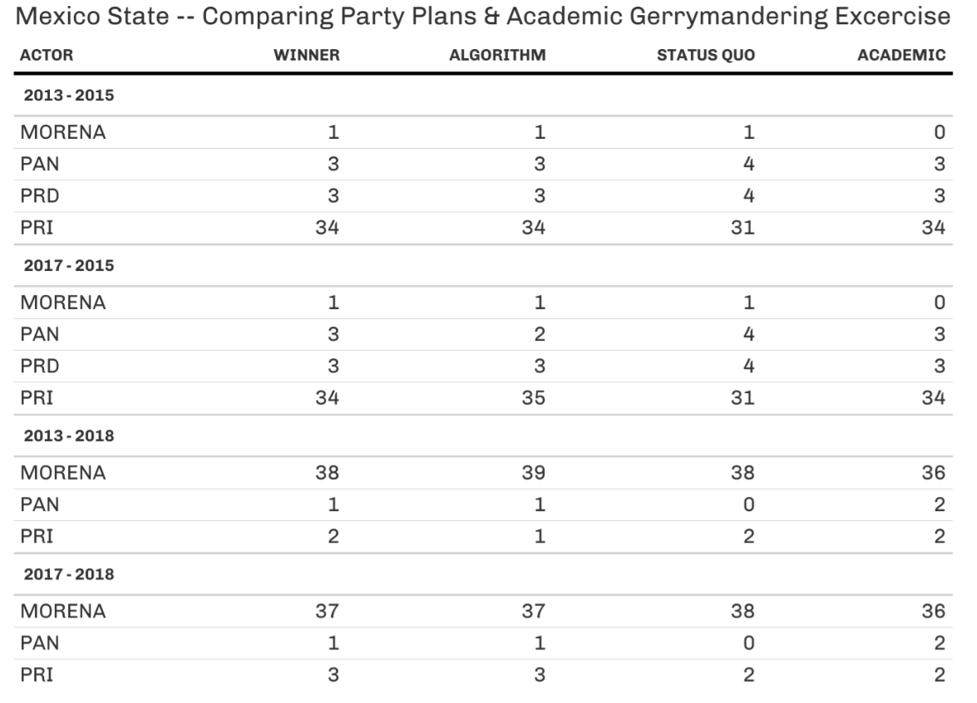
Table 2.2.1 Comparing party plans (2013 / 2017) vs an academic gerrymandering exercise favoring the PRI in the State of Mexico (EdoMex)

Results in table 2.2.1 show marginal differences in the distribution of seats in EdoMex. Based on the 2015 turnout, the PRI would have obtained 34 out of the 40 seats with the 2013 EMB´s algorithmic solution, the 2013 winning plan selected by the TC, or its best hypothetical scenario maximizing seat returns (academic solution). Results are almost identical when comparing the status quo and the academic plan with the 2017 algorithmic solution and winning plan. Based on the 2018 turnout, the seat distribution among parties in the EdoMex remains almost the same across the four scenarios of 2013 and 2017 (the PRI is slightly better – by one district in the winning category and two districts in the algorithmic category – with the 2017 plans than with the 2013 scenarios).
Figure 2.2.1 (a, b, c, and d) depicts the 2013 and 2017 electoral cartography for the algorithmic and winning solutions in the state of Guanajuato, a traditional stronghold of the right-wing party (PAN). The maps show how the electoral geography changed within and across redistricting cycles. The comparison of the 2013 vs 2017 algorithmic solutions (2a vs 2c), for instance, shows map differences that are a consequence of the EMB/TC’s decision to operationalize rules differently––despite both solutions being produced using the same 2010 baseline population, but with a different optimization. The comparison within processes (2a vs 2b and 2c vs 2d) also shows the boundary difference due to the interaction phase that took place between parties and bureaucrats. These changes, however, had a marginal implication in the distribution of seats across parties. Under the 2013 plan and using 2015 turnout, PAN wins 14 seats and MORENA 1 with the algorithmic solution. After parties engaged in the process, PAN won all 15 seats. With the 2017 plan, despite the changes in the north-western municipality of León, PAN kept all 15 seats in both the algorithmic and winning solutions.

Figure 2.2.1 (a, b, c, and d). Comparing algorithmic and winning plans in Guanajuato

- Algorithm 2013 b. Winning 2013
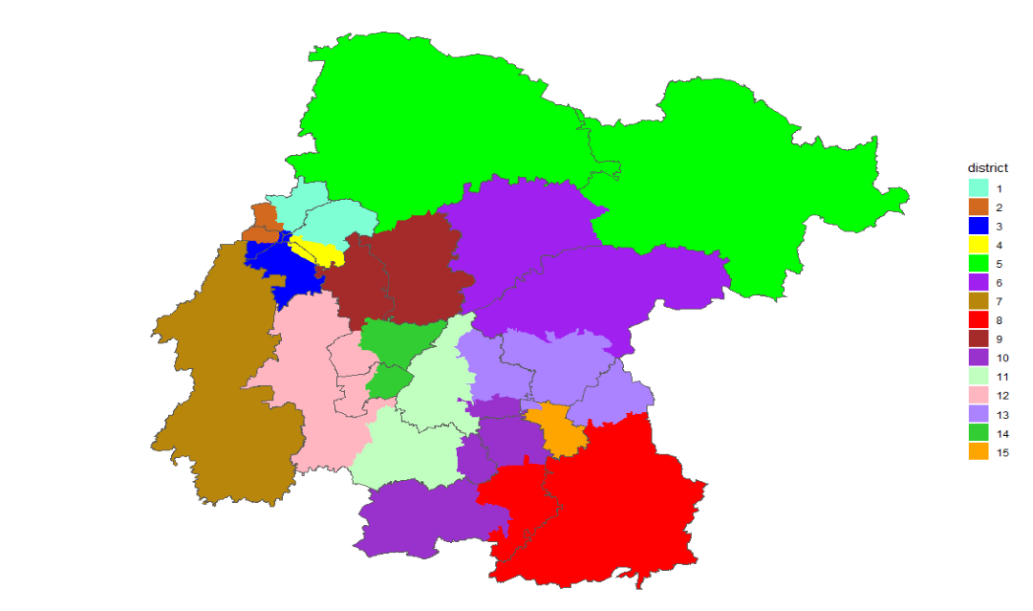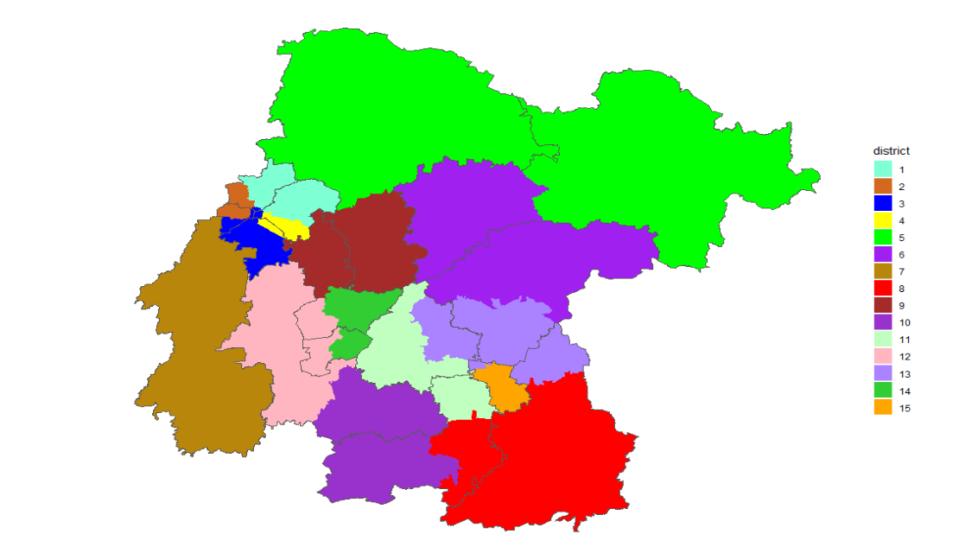

c. Algorithm 2017 d. Winning 2017
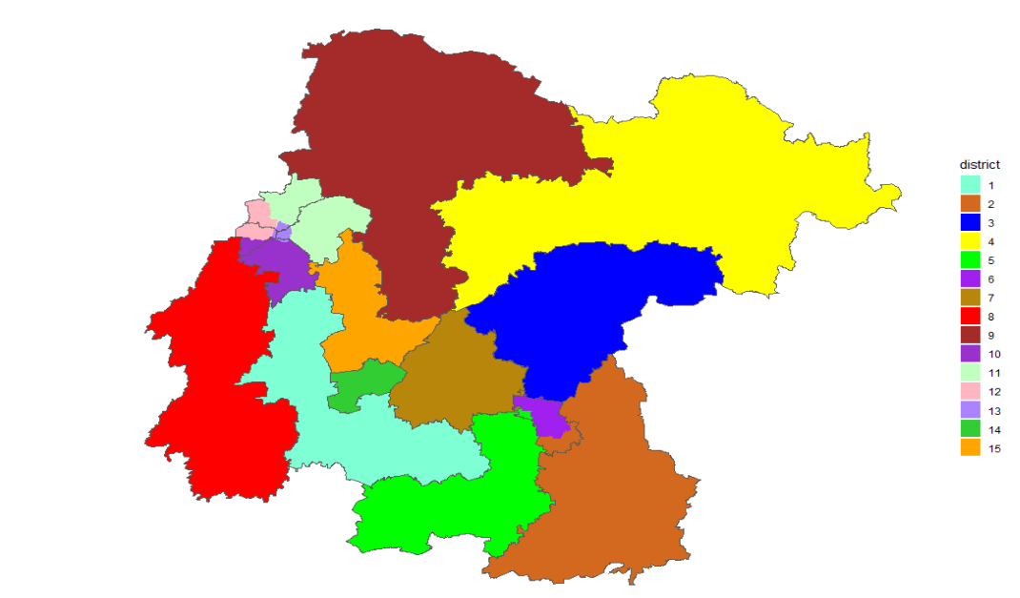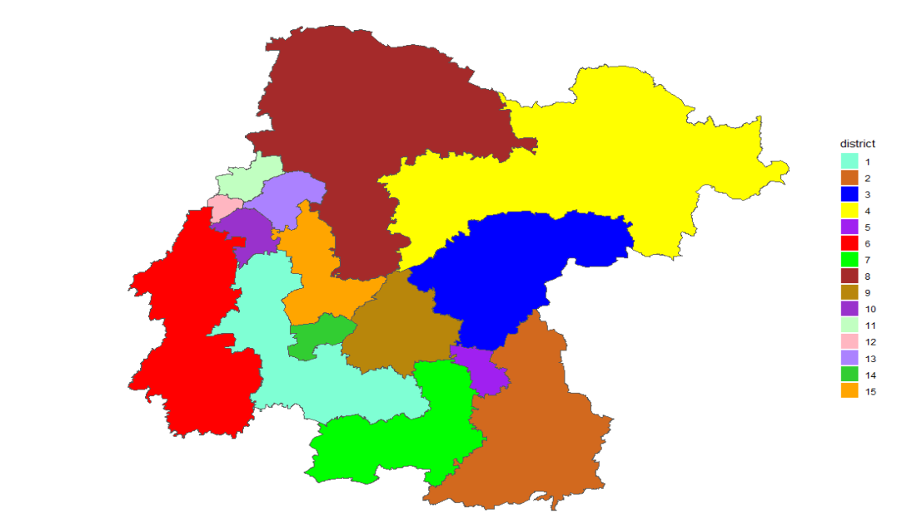

Appendix 3. Institutional constraints

3.1 Seccion differentials by actor at the stage and plan level
Figure 3.1.1 shows all the counter-proposals suggested by parties considered in each stage by the TC compared to the algorithmic solution. The different colors depicted in the legend represent the creator of the plan, namely: the bureaucracy (INE), a single party, a coalition of parties, or a plan endorsed unanimously by all parties. This figure reveals two patterns of partisan engagement. On one hand, it shows that an important number of partisan plans suggested alternatives that were above the 20% difference with respect to the algorithmic solution. It also shows that most of the interactions taking place in 2013 were skewed towards the 0 - 20% range, that they were mostly formulated by individual parties, and that the first round (M_{2,p}) had the highest number of plans (9) that were above the 30% difference. On the other, it shows that 2017 plans were more evenly distributed within the 0 - 45% range, and that they were formulated either by a coalition of parties or unanimously endorsed (contradicting Premise 3.2).

3.1.1 Seccion differentials by stage
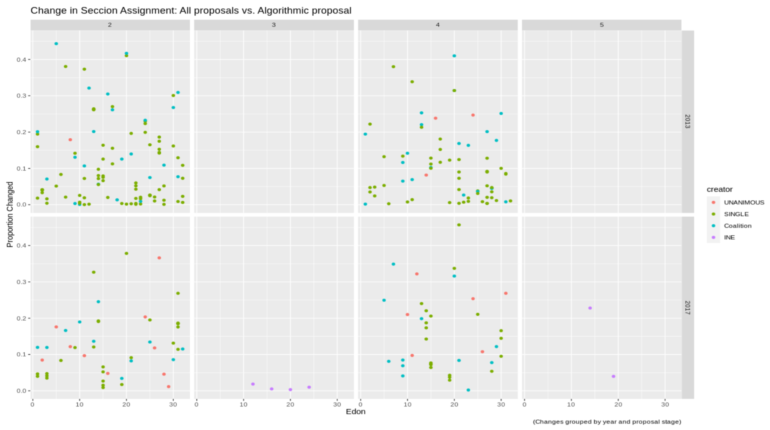
These findings reveal not only that the rules have not constrained the capacity of parties to formulate counter-proposals with a substantial deviation – of secciones – over time (against Premise 3.3), but that the adoption of slightly different procedural rules (i.e., criterion 8) has encouraged less individualistic engagement and more consensus-building among parties endorsing plans that are suggesting a substantial change in the number of secciones across districts.

3.2 Tradeoff analysis of redistricting criteria
Figure 3.2.1 shows the “tradeoff” between criteria in proposed plans (i.e., the score associated with the cost function, the deviation of the population across districts, the number of municipal splits, the level of competitiveness, and the average winning margins). As expected, the official score is correlated with population deviation (e.g., less deviation decreases the cost function). The number of municipal splits is also correlated with population deviation but, more importantly, it correlates with the level of competitiveness, which is partial evidence showing that municipal integrity is constraining partisan gerrymandering.

Figure 3.2.1 Tradeoff between redistricting criteria in proposed plans

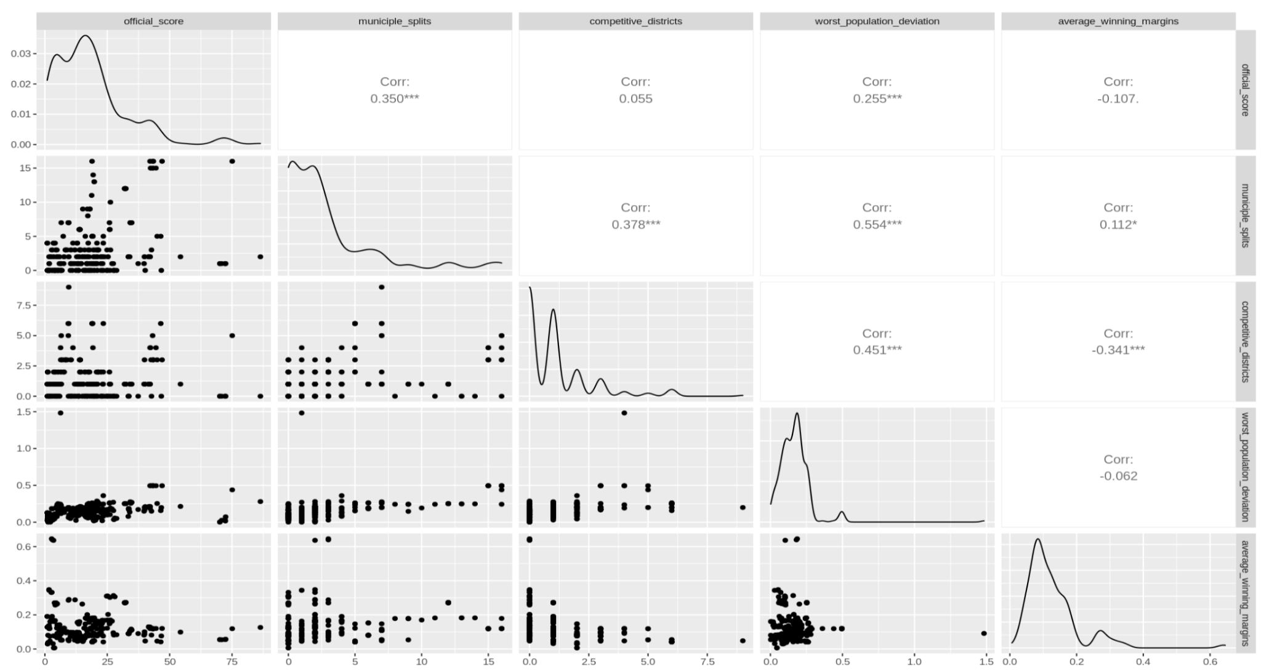
A hypothesis for explaining the lack of variation in the allocation of seats is that the interaction of rules with political demography is constraining the parties’ capacity to gerrymander. We evaluate this hypothesis using the theoretical limits of gerrymandering. That is, we compare the variation in the allocation of seats between a hypothetical – extremely aggressive – partisan gerrymandering strategy, which is only limited by the “equal” population constraint (allowing a +/- 15% deviation), and the variation observed with the interaction between pre-mapping redistricting rules (e.g., the choice to use secciones, contiguity, municipal boundaries) and the geographic distribution of electoral support within each state. We state this premise in the following way:

Premise 3.1 (Appendix). The interaction of rules with political demography is constraining the variation in the allocation of seats (if rules did not have an effect, the difference in the variation between the pre and post-rule application maps would tend to be closer to zero).

Table 3.2.1 depicts the “tradeoff” between criteria in proposed plans. We define "mapping freedom" as the range between the theoretical minimum and maximum possible seats a specific party could obtain during the mapping process – assuming the parties were sophisticated enough to find the possibilities left. We define "distribution freedom" as the variation in the number of seats conditional on the level of support parties receive in a specific year (e.g., the number of votes parties received within each state). The “difference of the pre-mapping constraints” (change 2018-2015) is defined as the difference between the distribution freedom and mapping freedom. This is the remaining variance that is attributable to some combination of pre-mapping redistricting rules (e.g., the choice to use secciones, contiguity, municipal boundaries) and their interaction with the geographic distribution of electoral support within each state. Given the existence of multiple parties and low turnout, it is theoretically plausible to minimize a party’s seats – assuming it does not matter what seats are won by other parties. This explains why the lower theoretical boundaries are so low across the board and do not vary substantially. The freedom of choice demonstrated by the mapping process (and available in theory over each year), however, varies significantly among parties.

Table 3.2.1 The tradeoff between redistricting criteria in proposed plans

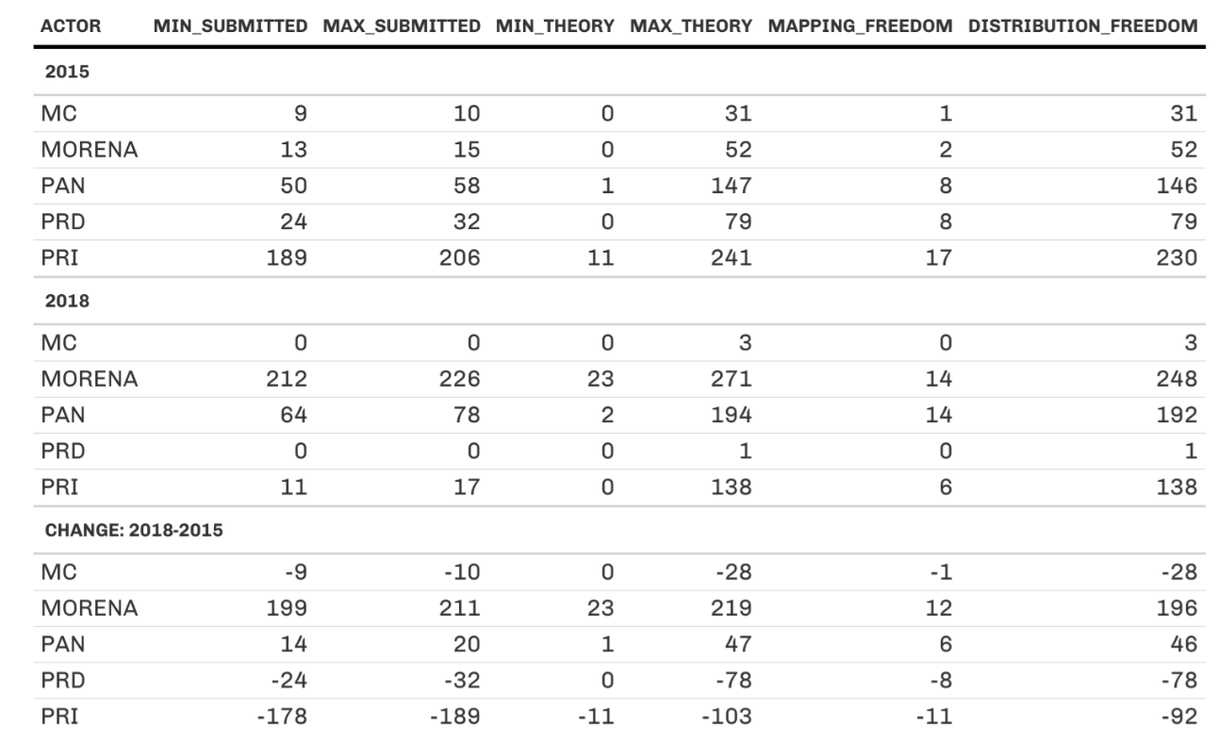

As expected, and confirming H8, these results show that the theoretical limits on minimal party seats are pretty low. That is, if the objective was to eliminate a party, and the only rule was equal population, this could theoretically be accomplished. As we have argued in section 3.1, there is substantial possible variation in the seat allocation based on the institution of redistricting (e.g., comparing a MMES and a nationwide PR system). Most of that effect, however, is eliminated by the adoption of redistricting rules and the distribution of support before any mapping/bargaining occurs. The 2018 swing in voter loyalty (distribution of support), for instance, significantly changed the upper bound of the theoretical distribution – by increasing to 219 and 47 seats for Morena and PAN, respectively, and by decreasing it to 103 and 78 seats for PRI and PRD, respectively.

Appendix 4. Party strategic interaction

4.1 Predicting party behavior based on political strongholds and electoral returns
In this subsection, we analyze party behavior from the higher level (strategy) perspective. We ask, why do parties engage in redistricting despite the marginal political implications on electoral returns? In order to evaluate the motivations behind parties' strategy to engage (dependent variable), we use three different measures as predictors of engagement assuming that parties are more likely to formulate a counter-proposal in those cases where they have a vested political interest – either because they are the ruling party, they are the second force competing for power in a particular state (and are interested in boosting electoral competitiveness), or because they are part of a state-level coalition running along with a major competing force in every state.
We believe that the parties that are ruling a state – or those that are competing for power – are more likely to engage in the process compared to those parties that play a marginal role and are not competitive in that particular state. Since smaller parties tend to rule (or have previously ruled) significantly fewer states than the traditional three largest parties (PRI, PAN, and PRD), we control for coalition formations at the state level in election years prior to the redistricting process. We assume that parties in the coalition will coordinate and endorse similar plans to support their well-entrenched running mates in every state.
As a proxy measure of the parties’ vested interest at the state level, we use the following three dimensions: i) ruling party; ii) coalition formation; and iii) vote returns. The first one captures a party’s “strategic position” based on its ruling condition (ruling vs opposition) and the level of competitiveness (e.g., if the state has recently experienced alternation in power once or multiple times). The second dimension focuses on the formation of state-level coalitions (e.g., while larger parties might have incentives to protect strongholds in a single-member majority system, smaller parties that are usually interested in competing within the PR tier might have an indirect incentive to endorse the same counter-proposal that their coalition mates shortly before or during the redistricting cycles). The third dimension captures the parties’ level of support based on the proportion of the vote share received prior to redistricting in every state.
After evaluating several hypotheses, treating a party’s decision to “engage” in the redistricting game as our dependent variable, we did not find any substantial results. Table 4.1.1 shows the percentage of entry – operationalized as a binary decision to formulate a plan or not in a specific state, regardless of the stage, year, or level – based on the parties’ strategic position. Surprisingly, the probability of partisan engagement is extremely high (above 90 percent) for almost all parties. Except for the second strategic position (significant at the 0.1 level), the prediction of entry – or intensity of engagement – based on the parties’ strategic position or vote share received at the state level prior to each redistricting cycle was not statistically significant.

Table 4.1.1 Likelihood of entry by the parties’ strategic position
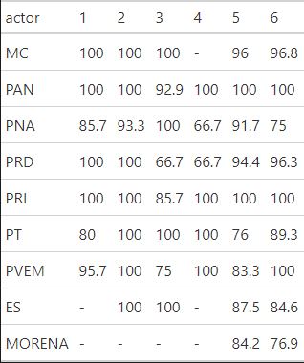
Despite the variation we identified previously at the lower level (individual actions depicted as M_{2,p} and M_{3,p} in figure 1), we suspect that the null findings are probably explained due to the high level of partisan engagement and the low-cost entry parties have for suggesting plans.

4.2 Modeling Partisan Engagement in 2013 and 2017
The selective strategy of partisan interaction described in tables 1 shows that parties are perceiving redistricting as a “high-stake” process to secure future electoral returns. Consequently, we test this assumption by evaluating if parties were more likely to engage when they had vested interests in a particular state (i.e., based on their ruling or competing status for the governorship, on the vote share received in previous elections, and on their role in a coalition as a major or minor party). We treat a party’s decision to “play” the redistricting game as our dependent variable. Each political party had an equal opportunity to participate in both the 2013 and 2017 processes and they were able to decide: i) if the participated in the process, ii) the number of times they formulated a counter proposal, iii) the states where they decided to propose a plan, iv) the timing of their intervention during the first and/or second round, and v) the channel used to formulate a counterproposal (national versus local representatives).
Regardless of the stage, level, or year, we evaluate the probability of partisan entry based on the party’s “strategic position.” We use this measure as a proxy for a party’s influence/power in a state based on its ruling condition and the level of competitiveness – number of alternations in power – in every state prior to redistricting. We defined six unique ordinal “strategic positions,” where the first position (1) corresponds to cases where parties have a clear vested interest given their “single-party rule” status, whereas six (6) corresponds to a scenario where parties are less likely to participate in the process given that they have never ruled a particular state, that there has never been alternation in power, and they represent a minor political force in that same state.
We also include the “vote share returns” obtained by all parties in the years preceding each redistricting process. Based on interviews with partisan representatives at the EMB, we suspect that parties used prior electoral returns at the state level to react to the algorithmic solutions and used this information to formulate alternative plans. For example, parties with higher levels of electoral support in a specific state – e.g., 60% or higher – are more likely to engage in the process than those parties that have traditionally received a lower vote share –e.g., less than 30%.
In order to account for the alignment of what we define as “major” and “minor” parties, we include information about state level coalitions that formed shortly before or during the year the redistricting process took place (Olmeda and Devoto 2019). In order to integrate coalitions into the “strategic position” framework, we assume that minor parties will adopt the same “strategic position” of the major party in the coalition or that all member parties assume the “strategic position” which is highest among the member parties in the coalition. For example, if PRI has a strategic position of one (1) and it forms a coalition with PVEM, which has a “strategic position” of six (6), all coalition members are considered to have a “strategic position” equal to one (1).
Assuming that partisan behavior is driven by a self-interest electoral maximization strategy, we evaluate the following premises:

Premise 4.1 (Appendix). [Engagement / Ruling Party]: A political party, or coalition of parties, with a higher “strategic position” will be more likely to propose a redistricting plan in a state compared to those parties holding a lower position, regardless of the redistricting process stage or the level of government from which the party is proposing.

Premise 4.2 (Appendix).. [Intensity of Engagement / Ruling Party] A political party, or coalition of parties, with a higher “strategic position” are more likely to engage in multiple stages and levels in a state compared to those parties holding a lower position.

Premise 4.3 (Appendix).. [Intensity of Engagement / Vote Share]: Parties with higher electoral returns are more likely to engage in the process compared to other parties that have received a lower vote share at the state level.
To evaluate premise 4.1 treating engagement as a binary dependent variable, we use a cumulative link model (CLM) as described by Christensen (2018). The CLM method allows for ranked ordinal categorical data to be incorporated into a logit regression model, while standard logit models do not account for ordinal rankings (e.g., first strategic position being of higher order than 6). For premises 4.2 and 4.3 we use an ordinal logistic regression to evaluate the relationship between the intensity of engagement and the parties’ vested interest based on either their strategic position (premise 4.2) or the past vote share they received in a particular state (premise 4.3). Table 4.2.1 shows the results for the models related to our three hypotheses.
Table 4.2.1. Predicting partisan engagement in the 2013 and 2017 redistricting processes

Strategic Position | H9.  Engagement  (Y/N) / Ruling Party | H10.  Engagement  Intensity / Ruling Party | H11.  Engagement  Intensity / Vote Share
1 | -0.520 | -0.824 **** | -
2 | 1.615* | 0.834 *** | -
3 | 0.554 | -0.174 | -
4 | -1.045 | 0.013 | -
5 | 1.135 | 0.185 | -
Vote  Share | - | - | 0.005 **
Note: The CLM was used for H9 (binary DV), while an ordered logistic regression was used for H10 and H11 (ordinal DV ranging from 0-4). Reported p-values: .001(****), .01(***), .05(**), and .1 (*).

The first model shows that only the second “strategic position” was a significant predictor of engagement (treated as a binary DV) at the 95% level. Since each category of the independent variable is treated as a binary variable, the first category is dropped (included as beta_0). The negative coefficient indicates that parties in the second “position,” are less likely to propose a redistricting plan (have E (Y =1|X)) compared to the “strategic position” previous to it (e.g. the second “position” is less likely to propose than the first). The rest of the “strategic positions” do not have a significant effect on a party’s decision to engage. The relative difference between the first and second positions, while significant, is negligible probably due to the fact that when engagement is treated as a binary dependent variable, parties unconditionally propose plans at a rate of 90%.
Similarly, the prediction of entry – or intensity of engagement – based on the vote share parties received at the state level prior to each redistricting cycle was not statistically significant.

4.3 The case of Yucatan
The records reveal that parties used a wide range of arguments related to administrative and socioeconomic characteristics to invoke criterion 8. Beyond showing their interest in the state’s capital (the city of Mérida) electoral boundaries, these stories provide very little information allowing us to infer their real motivations. For example, the arguments offered by the parties centered around how Mérida, which concentrates two federal districts, should be split. Traditionally, these two districts split the city vertically (East-West), while the algorithmic solution offered a horizontal (North-South) split. The right-wing PAN, which has traditionally been the second competing force to the PRI in the state and a dominant force in the capital, argued the following to justify its “flipping” decision from the first to the second stage: i) the partisan higher-scoring plan (1.705) will allow INE’s district headquarters to remain in the municipalities where they are currently located, ii) the adoption of the higher-scoring solution will allow the EMB to maintain a lower population deviation in the future, considering a higher expected population grow in certain areas of the city, and iii) the lower-scoring algorithmic solution offering a North-South split of the city would create a northern district concentrating higher-earning residents, which “usually do not get involved” in participating as poll workers on the election day. None of these arguments are related to a seat/vote maximizing electoral strategy and very similar reasons were posed by the rest of the parties.
What drove parties to interact the way they did in Yucatán? After talking to the party representatives at the state level, the PAN representative explained that during the first round of interaction their party was trying to offer a lower-scoring solution that would allow them to maintain a safe district in the north of Mérida with a horizontal split. After a conversation with the PRI representative, however, he confirmed that the PAN accepted a vertical split of the capital because they realized that their party would still be able to retain the capital’s northern district while becoming more competitive in the southern district of Mérida. In exchange, the PRI would try to minimize PAN’s historic advantage in the northern district of the capital. In the 2018 election, results confirm that the PAN benefitted from “switching” positions between the first and second round. The PAN won the northern district with a safe margin of 29,405 (12%) votes and managed to win the southern district by only a 98 (0.04%) vote difference. If the algorithmic lower-scoring plan had prevailed in 2017, PAN would have only been able to retain one of the two capital’s districts (the northern district of Mérida) in the 2018 and 2021 elections.
These explanations partially justify the actions of some of the parties (e.g., either in an administrative sense when arguing that their plans will solve problems related to the bureaucratic organization or by learning that they could benefit from what other parties are proposing when invoking unanimity). However, they reveal that the logic used by parties when engaging is not being driven exclusively by a vote/seat maximizing rationale.
In the light of the 2018 and 2021 electoral results, for instance, it is difficult to explain why did the PAN endorse the algorithmic solution in the first round (splitting Mérida horizontally) if an alternative plan (with a vertical split of Mérida) was clearly allowing them to win both districts —versus winning only the northern district of the capital in both the 2018 and 2021 elections (as shown in figure 4.3.1).

Figure 4.3.1 (a, b, c, and d). Comparing algorithmic and winning plans in Yucatan for the 2013 and 2017 redistricting cycles

- Algorithm 2013 b. Winning 2013 (PAN Endorsed)

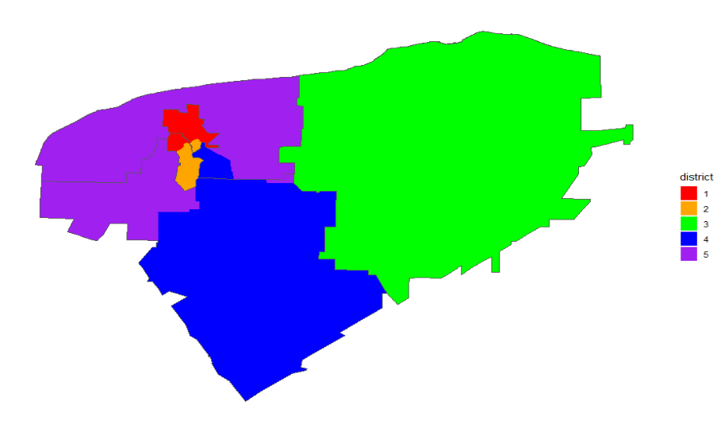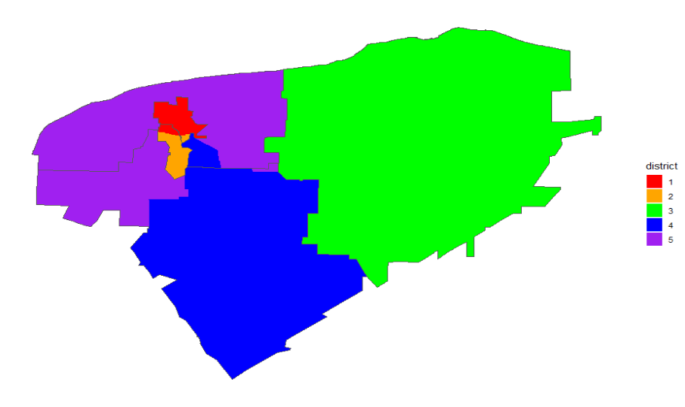

c. Algorithm 2017 d. Winning 2017 (PAN endorsed)

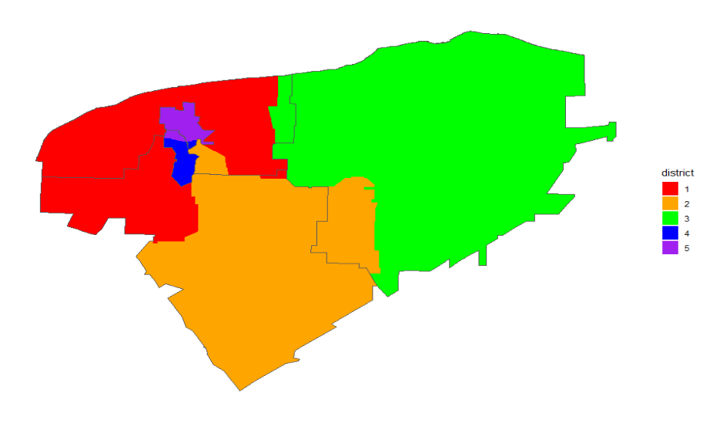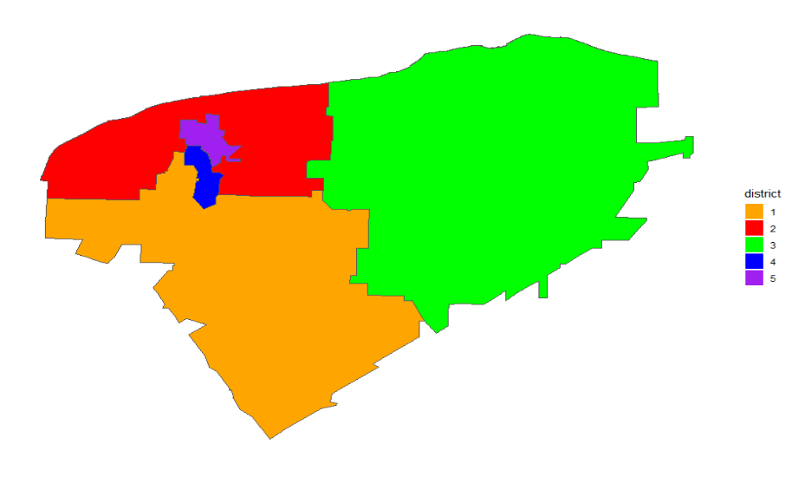
Note: Maps elaborated by the authors with information from the Instituto Nacional Electoral.

It is also surprising that both the other dominant forces at the state level—the PRI, MORENA, and its smaller coalition allies–– did not opt to veto the higher-scoring unanimous solution. More surprisingly, perhaps, is the fact that they were the main actors supporting the higher-cost vertical (East-West) divide that would end up benefiting the PAN´s electoral rentability in the state’s capital (as shown in Table 4.3.1).

Table 4.3.1 (a and b). Political implication of party interaction in Yucatán during the 2013 and 2017 redistricting cycles (using 2015 and 2018 turnout)
- 2015 Turnout
Party | Algorithm (2013) | Final Plan  (2013) | Algorithm  (2017) | Final Plan  (2017)
PRI | 4 | 4 | 4 | 4
PAN | 1 | 1 | 1 | 1

Note: Using 2015 turnout. Table calculated by the authors. Cells report the number of districts won by each party.

- 2018 Turnout
Party | Algorithm (2013) | Final Plan  (2013) | Algorithm  (2017) | Final Plan  (2017)
PRI | 3 | 3 | 3 | 3
PAN | 1 | 2 | 1 | 2
MORENA | 1 | 0 | 1 | 0

Note: Using 2018 turnout. Table calculated by the authors. Table calculated by the authors. Cells report the number of districts won by each party.

Appendix 5. Algorithmic efficiency and score difference in the 2013 and 2017 processes.
From the optimization standpoint, algorithmically produced plans were more successful (effective) in 2017 than in 2013. In the former, the EMB adopted 9 unchanged automated plans, while in the latter it only adopted 5. Since a lower score is associated with a more efficient plan (in terms of maximizing the restrictions), we would expect that plans with lower scores to be preferred to plans with a higher cost. Figure 5.1 shows not only that this did not always happen (either because a rule was violated or a socioeconomic consideration was made by the TC), but that the patterns of interaction and evaluation of plans significantly changed at the state level yielding to different outcomes.

Figure 5.1 Algorithmic Score Efficiency by State and Year
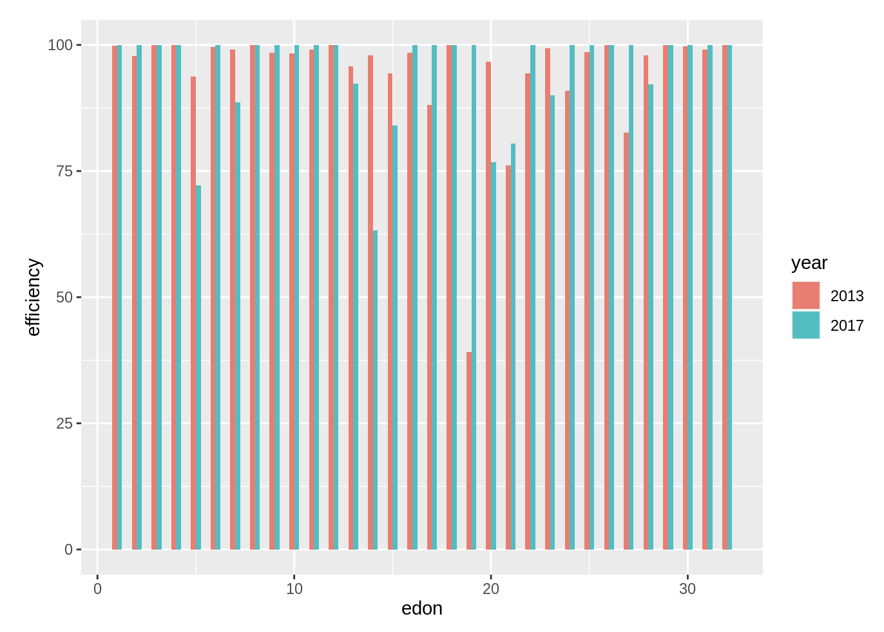
Even more surprising, is that the proportion of unexpected winners was disproportionately high in 2017. Results in table 5.1 show that while in 2013 only in 15% of the cases the algorithmic solution was adopted, algorithmic success increased to 28%. They also show that the optimum solution found by the computer was rejected in more than two thirds of the cases in both years (84.38% in 2103 and 72% in 2017). Furthermore, it reveals that in a large number of cases, especially in 2017, 72% of the time the best score was not adopted.
Lastly, we find that unanimous endorsed plans were extremely more common in 2017 (22% vs 3%) – due to the adoption of criterion 8, but also that the EMB/TC adopted a significantly higher number of plans in 2017 that were not the “best-scoring plan” and that were not endorsed unanimously by all actors (31% vs 19%). This evidence shows that despite there was an improvement across processes in terms of algorithmic efficacy, the best solutions were either rejected because parties were able to beat the algorithm in 2013 or because both the EMB/TC and political parties (via criterion 8) rejected the algorithmic solution.
Table 5.1 Unexpected Winners
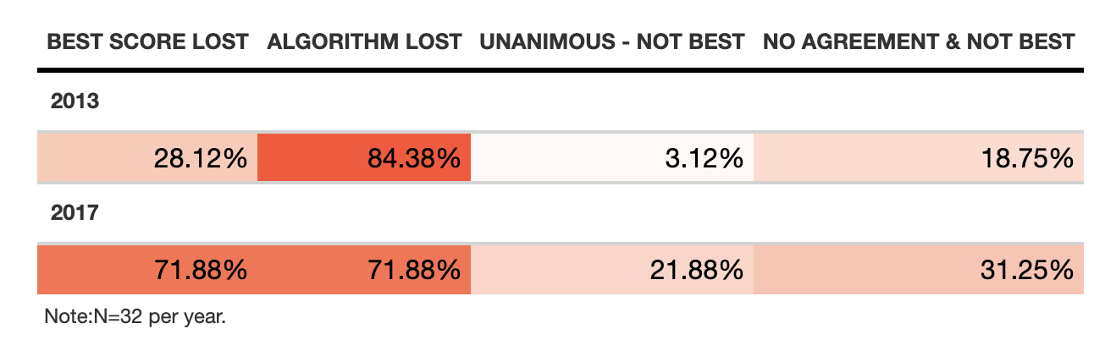

Finally, the figure shows how the adoption of criterion 8 in 2017 made the adoption of consensus and unanimous plans a more frequent solution. This clearly affected the adoption of more “efficient,” but facilitated the negotiation between parties and reduced the apparent administrative rule violations observed in 2013 when the TC adopted plans with a higher cost. Although in 2017 only two cases were observed in states 14 and 19, the final plans were introduced by the EMB despite partisan or automated plans with lower scores were documented. Figure 5.2 summarizes the 2013 and 2017 redistricting cycles by stage.

Figure 5.2 Redistricting Process Stages and Winners
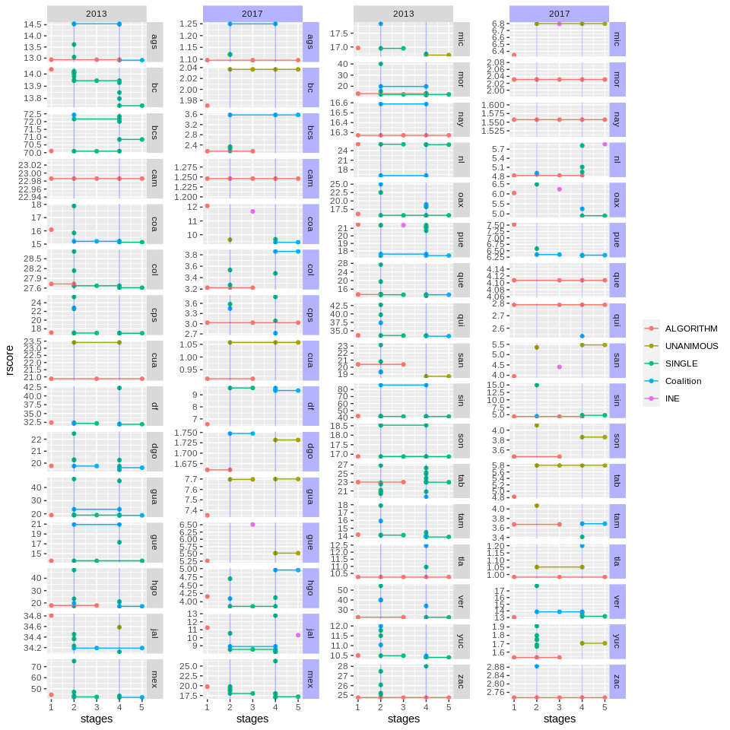
Note: Figure created by the authors. Source: IFE/INE reported scores during the 2013 and 2017 redistricting processes.

Appendix 6. Proposal Differences Details

Table 6.1 Counterproposal Differences by Actor Type
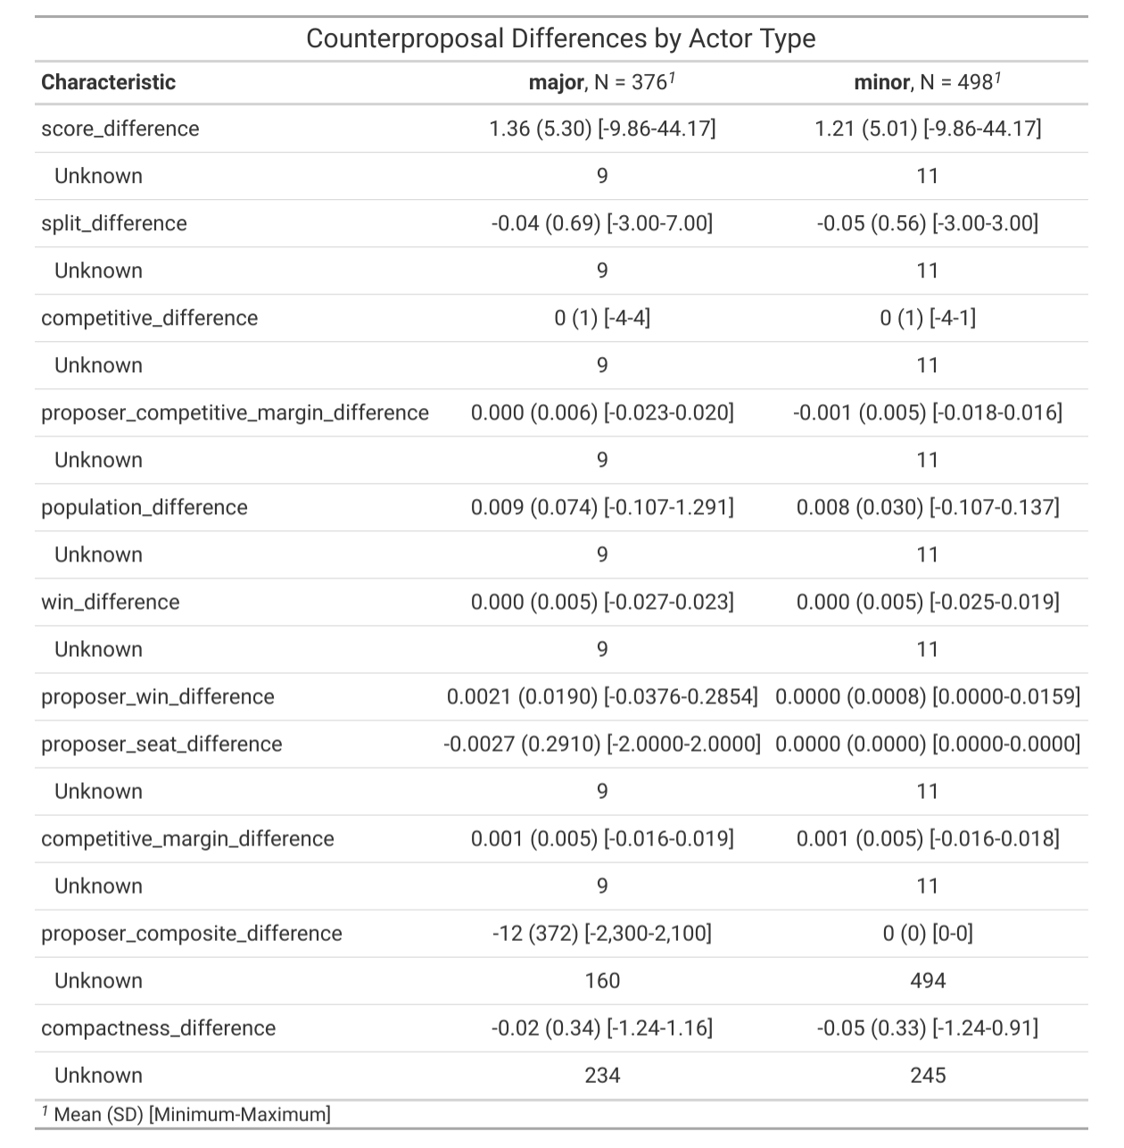

Table 6.2 Unanimous Proposals - Differences vs Reversion
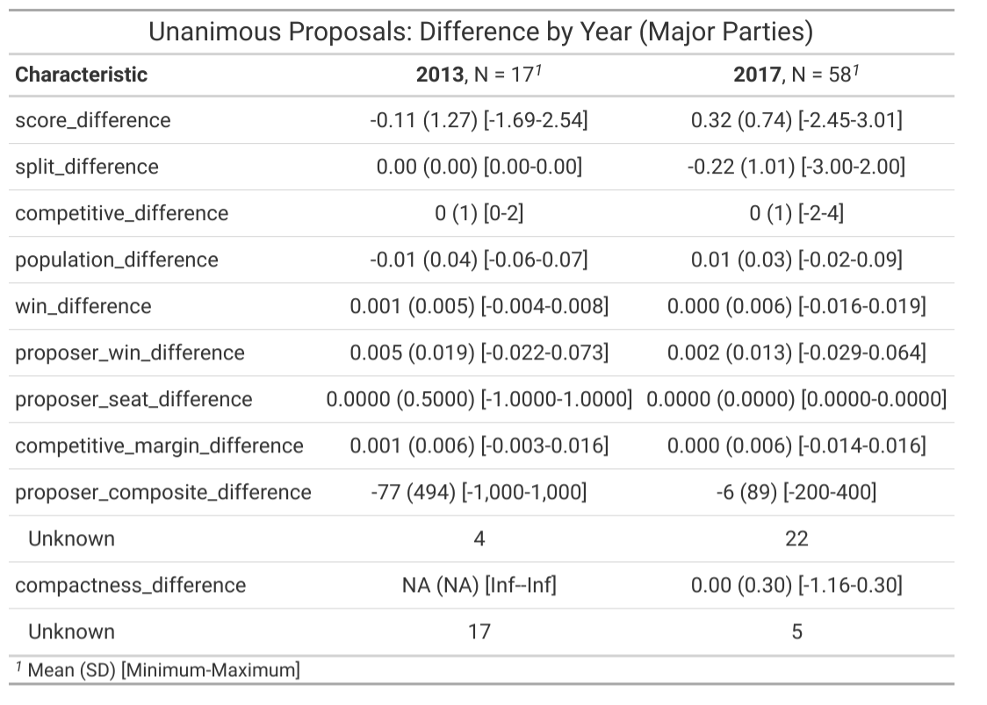

Online Appendix References
Altman, Micah and Michael P. McDonald (2010). The promise and perils of computers in redistricting. Duke J. Const. L. & Pub. Pol'y, 5, 69.
Altman Micah, B Amos, MP McDonald, and DA Smith. 2015. Revealing preferences: Why gerrymanders are hard to prove, and what to do about it. Available at SSRN 2583528.
Cantú, Francisco. "The fingerprints of fraud: Evidence from Mexico’s 1988 presidential election." American Political Science Review 113, no. 3 (2019): 710-726.
Christensen, R. H. B. (2018). Cumulative link models for ordinal regression with the R package ordinal. Submitted in J. Stat. Software, 35.
Cox, Gary. 1997. Making Votes Count: Strategic Coordination in the World’s Electoral System. Cambridge: Cambridge University Press.
Estévez, Federico, Eric Magar and Guillermo Rosas. 2008. “Partisanship in Non-Partisan Electoral Agencies and Democratic Compliance: Evidence from Mexico’s Federal Electoral Institute.” Electoral Studies 27(2):257–71.
Gronke, P. and Wilson, J.M., 1999. Competing Redistricting Plans as Evidence of Political Motives: The North Carolina Case. American Politics Quarterly, 27(2), pp.147-176.
IFE. 2004. “Acuerdo del Consejo General del Instituto Federal Electoral por el que se aprueban los criterios y consideraciones operativas que se utilizarán en la formulación de los proyectos de división del territorio nacional en trescientos distritos electorales federales uninominales, así como la creación del Comité Técnico para el seguimiento y evaluación de los trabajos de distritación.” Acuerdo del Consejo General del IFE CG104/2004.
Johnson, Kennetg F. 1978. Mexican Democracy: A Critical View. New York: Praeger Publishers.
Kousser, J.M., 1991. The voting rights act and the two reconstructions (pp. 213-270). University of Georgia Press.
Langston, Joy. 2017. Democratization and Authoritarian Party Survival: Mexico’s PRI, 1982–2012. New York: Oxford University Press.
Levitsky, Steven, and Way, Lucan A. 2010. Competitive Authoritarianism. New York: Cambridge University Press.
Lujambio, Alonso. 2000. El poder compartido: un ensayo sobre la democratización mexicana. México: Océano.
Lujambio, Alonso and Horacio Vives. 2008. From politics to technicalities: Mexican redistricting in historical perspective. In Redistricting in Comparative Perspective, ed. Lisa Handley and Bernard Grofman. Oxford: Oxford University Press.
Mayhew, David R. 1974. Congress: The Electoral Connection. New Haven: Yale University Press.
Michel, Aurélia and Antonine Ribardière. (2017. Crecimiento demográfico y formas de urbanización de las pequeñas ciudades en México. Territorios, 37, 101-121
Moreno, A. 2018. El cambio electoral: votantes, encuestas y democracia en México. Ciudad de México: Fondo de Cultura Económica, 2018, 259 p. ISBN 9786071657756.
Olmeda, Juan Cruz and Lisandro Martín Devoto (2019). ¿Together or Apart? Assessing the Success of Electoral Coalitions at the Subnational Level in Mexico. Revista Mexicana de Ciencias Políticas y Sociales. 64 (235).
Pérez‐Campuzano, E., Castillo Ramírez, G., & Galindo Pérez, M. C. (2018). Internal migration in Mexico: Consolidation of urban–urban mobility, 2000–2015. Growth and Change, 49(1), 223-240.
Samuelson, Paul. 1948. “Consumption Theory in Terms of Revealed Preference.” Economica 60: 243-53.
Schedler, Andreas. 2002. “The Menu of Manipulation.” Journal of Democracy 13 (2): 36–50.
Scott, Robert E. 1964. Mexican Government in Transition. Urbana, IL: University of Illinois Press
Sobrino, Jaime. 2018. Conociendo (un poco más) la migración interna de México. El Colegio de México. Otros Diálogos, Número 4.
______. 2017. Redistricting, Transparency, and Political Representation of Minority Groups in Mexico: 1990-2017. In Luis Carlos Ugalde y Saíd Hernández Quintana, Strengths and Weaknesses of the Mexican Electoral System, 1990-2017. Federal and Local Perspectives. Mexico City: Electoral Tribunal (TEPJF).
Trelles, Alejandro and Diego Martínez. 2007. Fronteras electorales: aportaciones del modelo de redistritación mexicano al estado de California Ba. thesis ITAM.
Trelles, Alejandro, Micah Altman, Eric Magar and Michael P. McDonald. 2023. “No Accountability without Transparency and Consistency: Evaluating Mexico’s Redistricting-by-Formula.” Election Law Journal: Rules, Politics, and Policy, 22:1, 80-99.
Varian, Hal R. 2006. “Revealed Preference,” in Samuelsonian Economics and the 21st Century, Michael Szenberg, ed. Oxford: Oxford University Press.
Weldon Uitti, Jeffrey A. (2005). "Mexico: Democratization Through Electoral Reform". En Reynolds, Andrew ; Reilly, Ben; Ellis, Andrew (comps.). Electoral System Design: The New International IDEA Handbook. Stockholm, Sweden: International Institute for Democracy and Electoral Assistance.
Woldenberg, José. 2012. Historia mínima de la transición democrática en México. México DF: El Colegio de México.

Paper prepared for delivery at the International Political Science Association, Lisbon, Portugal, July, 2021. We thank the National Electoral Institute (INE) and the Federal Voter Registry (RFE). Special thanks to INE’s Cartography Department and its late Director, Miguel Ángel Rojano (1996-2021), for sharing their experience with automated redistricting since 1996 and most of the data we analyze. The corresponding author acknowledges the support of the Politics Department, as well as the Tomberg and Norman funds at Brandeis University. We thank Federico Estévez for his comments, as well as Brandon Stanaway, Erika Karlin, and Maggie Schealy for their research assistance. Lastly, we thank Juan Cruz Olmeda and Lisandro Martín Devoto for generously sharing with us their state-level coalition dataset (Olmeda and Devoto 2019).
We describe contributions to the paper using a standard taxonomy (Allen, Brand, Scott, Altman and Hlava 2014). A. Trelles (AT) and M. Altman (MA) were lead authors, having taken primary responsibility for writing. AT prepared the original draft and is the corresponding author (atrelles@brandeis.edu). E. Magar (EM) and M. McDonald (MM) contributed to writing through editing and review. All authors contributed equally to conceptualization. AT lead methodology, with contributions from MA. AT lead data curation, with contributions from EM.
Recent contributions to the study of redistricting in semi-competitive or consolidating democracies include the work of Wong (2019), which explores how electoral boundary delimitation can be used to the advantage of ruling parties in electoral authoritarian regimes; Kasara (2014), who studies the link between electoral geography and political violence in Kenya; and Daxecker (2020), who examines the relationship between malapportionment and violence in India. Martínez i Coma and Lago (2018) study offers a comparative study of gerrymandering showing that the effects of partisan bias tend to be larger in countries with majoritarian systems.
The Federal Electoral Institute (IFE, now INE) has been redrawing Mexico’s political geography of 300 majority districts across 32 states since 1996. After the 2014 electoral reform, the board’s name changed to National Electoral Institute (INE), reflecting its aggrandized authority over subnational elections. We avoid cluttering the text with acronyms by referring to the IFE/INE as “the independent board or EMB,” or simply “the board” in the text.
According to V-Dem’s de facto measure of electoral autonomy (EMB autonomy), Mexico’s INE ranks as the 5th most autonomous electoral commission in Latin America. International organizations, such as the Organization of American States (OAS), International IDEA, or Democracy International, have publicly and repeatedly acknowledged the decades-long work of the INE.
Since MORENA’s arrival to power in 2018, AMLO has referred to INE’s electoral commissioners as “Individuals attempting to derail democracy. On one hand, they simulate being democrats but, on the other, they flagrantly violate the Constitution and the electoral statutes, and have either executed or applauded electoral frauds in the past. Now, they try to appear as the true champions of democracy.” (Manetto 2021).
This initiative was rejected by the Supreme Court after a mass mobilization took place in major cities across the county. For additional details on the reform initiative, see Raphael (2022).
On May 8, 2023, Mexico’s Supreme Court invalidated this electoral reform arguing the legislative process had been infringed. See Sheridan (2022), Fuentes (2023), and SCJN (2023).
Upon publication, the complete range of partisan counter proposals will be made publicly available. Please contact the corresponding author for questions and preliminary access to the data and replication code. A temporary repository is available at Harvard University's Dataverse website: https://dataverse.harvard.edu/dataset.xhtml?persistentId=doi:10.7910/DVN/PYRXGE.
Since 1978 Mexico has a mixed-member electoral system where the lower house is formed by 300 single-member districts and 200 closed list proportional representation seats (Weldon 2005). Redistricting affects only the former tier and the interest parties have on the configuration of single member districts is independent of the proportional tier. See online appendix 1.1 for a detailed account of redistricting in Mexico.
In 2004, for instance, 24 (out of 300) indigenous majority districts were established for the first time by the EMB. In the 2022 redistricting process, INE established 44 (out of 300) districts to protect the representation of minority groups.
See online appendix 1.2 for a detailed description of partisan interaction.
Parties can submit plans either through their national representative at the National Oversight Commission (known as CNV) or the state level Local Oversight Commission (known as CLVs in each one of the 32 states). In case the same party submitted plans through both channels, the TC would consider the plan with the lowest score. See online appendix 1.2.
In the 2017 redistricting process, the electoral tribunal (TEPJF) mandated the EMB to include for the first time the public input from indigenous minority communities during the first round of counter-proposals (Trelles 2017). In this article, we omit the analysis of any observations derived from this consultation in order to focus on partisan strategic interaction.
We compare the difference between the 2013 and 2017 first scenarios as a way to examine the ex-ante effect, as well as the difference between the algorithmic and final plans that were submitted to the Consejo General in 2013 and 2017 to analyze the ex-post partisan effect.
According to former IFE’s President, Leonardo Valdés, it was the PAN that negotiated with the ruling party (PRI) to postpone the redistricting process after the 2015 mid-term election because the right-wing party believed they would lose seats to the PRI. In order to approve the reform, which was part of a political agreement called “Pacto por México,” the PRI agreed to postpone the federal redistricting until INE was established in 2014 and the 2015 election was conducted with the 2004 electoral geography. Interview of the leading author with Leonardo Valdés. Mexico City, April 2015.
According to INE’s Cartography Director, the INE decided to repeat the redistricting process using a slightly different formula in the optimization phase in 2017 to minimize the changes that could be introduced by parties. Interview of the leading author with Miguel Rojano, INE’s Director of Cartography. Mexico City, June 2019. See online appendix 5 for a description of algorithmic efficiency.
According to Miguel Rojano, INE’s late cartography director (1996-2021), the Executive Board adopted this rule in 2017 “in order to consider socioeconomic characteristics that were left out of the optimization process as long as parties decided to unanimously endorse that solution.” Interview of the leading author with Miguel Rojano, INE’s Director of Cartography. Mexico City, June 2019.
See footnote 7.
Morena formed an electoral coalition ––Juntos Haremos Historia–– with two smaller parties, the PT and the PES.
We analyze this level––the likelihood of engagement based on the type of party, vested electoral interest, and coalition status––in section 5.1 of the online appendix.
See:https://www.elfinanciero.com.mx/nacional/amlo-arremete-contra-consejeros-del-ine-forman-parte-del-regimen-corrupto-dice/
Our analysis of the overall effect of rules, criteria, and implementation is limited because we are unable to observe variation in INE’s criteria. We do, however, inform some proximate questions based on the actual data we observe.
See online appendix 5 for a description of algorithmic efficiency.
For the perfect foresight hypothetical comparison, we consider differences higher than 30 seats (10% of the 300 single member districts) to be significant. If the range between the best and worst possible plans is significant (higher than 30 seats), this means there is space for discretional administrative decisions that could benefit or affect a party.
Historically, the bureaucracy has deemed this criterion as one of the most relevant restrictions to be considered when renewing the electoral geography in Mexico (Trelles and Martínez 2007). Since 1996 it has been considered one of the key restrictions of the process. In 2004, for instance, municipal integrity was included for the first time in the optimization phase as the third (out of four) restrictions used in the algorithm. The other three restrictions are population balance, geometric compactness, and traveling time (INE 2005 and Trelles and Martínez 2007). In 2013, municipal integrity became the second (out of four) most important restriction in the algorithm – preceded by population balance and followed by traveling time and geometric compactness in the third and fourth place, respectively. In 2017, the TC decided to remove municipal integrity from the optimization phase. The bureaucracy, however, did an ex-ante classification setting apart – from the optimization – those municipalities that had the sufficient population to form a district within the allowed 10-15% population deviation margins and identifying those municipalities that had more than 40% of indigenous population.
Most municipalities in Mexico have less population than the average electoral district , which approximately groups 350 thousand people (e.g., out of the 125 municipalities in the EdoMex, which is the most populated state in the country, only 12 of them have the sufficient population to have one or more electoral districts).
Upon publication, all data and code will be made publicly available (see footnote 9).
In 1960, 32 proportional representation seats known as “diputados de partido” were introduced in the country’s electoral system. 32 PR seats (out of the 200) were introduced in the lower chamber.
This system allowed opposition minority parties to significantly increase their congressional representation over time. Even when 40% of the seats belong to the PR tier, the 300 majority districts have been key to preventing the party system's extreme fractionalization and maintaining the dominance of large political parties (Cox 1997). We conjecture that eliminating the 300 single-member majority districts would have a long-term effect that would: a) significantly alter the dynamics of political competition, b) affect the rationale of both electoral and legislative coalitions, c) increase elites’ control over the PR lists, and d) weaken the connection between majority constituencies and their representatives (Morgenstern 2003, Morgenstern and Siavelis 2008, and Colomer 2018). If an electoral reform favoring PR were to be adopted in Mexico, this would not be the first time the majoritarian party would decide to alter the rules of electoral competition. In the late 1970’s the PRI introduced proportionality to allow opposition parties to access legislative representation. While this change made the PRI eventually lose its majoritarian status, the closed list system increased the elites’ control of their parliamentary rank and file and weakened the electoral connection between representatives and their constituents.
We do not discuss or evaluate the implications of MORENA’s 2022 initiative to alter Mexico’s electoral system – promoting a shift towards pure proportionality – in this paper because the parties’ adaptation to a new system would depend on its characteristics (e.g., using closed vs open or national vs state lists).
Based on the 2015 election results and the 2004 cartographic baseline, the seat difference between a purely PR electoral system versus a MMES would be as follows: the PRI would have lost 53 seats, while smaller parties such as MC, PNA, PES, and PT would have won 7, 9, 9, and 9 additional seats respectively.
In this paper we focus exclusively on the 300 majority districts and treat them as an independent group from the PR tier. We assume the country’s governability rule adopted in 1996 (la cláusula de gobernabilidad) does not alter neither the criteria and rules used to produce algorithmic plans nor the parties’ incentives to maximize their electoral returns in majority districts once an algorithmic plan has been generated.
Fieldwork interview of the leading author with Florencio González, PAN’s representative at IFE’s CNV. Mexico City, June 2019.
We use the following parameters to classify seat differences based on the total universe of 300 single member districts at play: 0-15 (0-5%) seat difference as marginal; 16-30 (6-10%) as minimal; 31-45 (11-15%) as significant; 46-55 (16-20%) as substantial; and >56 (>21%) as pronounced. To evaluate our premises we use a baseline category based on our expectations.
We found no significant deviations across scenarios focusing at the state level (based on large and medium size states) or using competitiveness as an alternative metric to seat maximization. See online appendices 2.1 and 2.2 for an analysis based on the level of competitiveness and on seat allocation at the state level. Also, using a two (in 2013) versus a four-restriction algorithm in 2017 had a minimal impact on parties’ seat distributions (the largest impact was a 3-seat loss difference for PAN), which suggests that duplicating the redistricting process in 2017 with slightly different criteria was, to say the least, redundant.
For example, in most cases large and small parties lose or win 1 to 3 seats when comparing the status quo with the winning plan in both the 2013 and 2017 process. Difference calculated based on the results we present in Table 2.
Ibid.
We use the following parameters to evaluate the degree to which plans changed between and within processes. We classify scenarios based on the difference in the proportion of secciones between plans: 0-5% difference as marginal; 6-10% as minimal; 11-15% as significant; 16-20% as substantial; and >21% as pronounced.
In order to overcome this procedural constraint, the EMB adopted in 2017 the unanimity rule (criterion 8) allowing parties to formulate higher-scoring plans as long as no other party vetoes that solution (unanimous solutions). Historically, the EMB has included “municipal integrity” as one of its main criteria when updating districts. The EMB, for instance, tries to minimize municipal splits and assigns prior to the optimization phase a district to those municipalities that have the sufficient population to be within the legal margin – e.g., +/- 10% to 15% deviation from the mean. In highly populated areas, however, municipalities need to be fractioned either because several districts are embedded within a single municipality or because a municipality does not have the sufficient population to receive its own district. Interview of the leading author with Miguel Rojano, INE’s Director of Cartography and with Florencio González, PAN’s representative at IFE’s CNV. Mexico City, June 2019. For a detailed description of algorithmic efficiency for the same period see Trelles et al., (2023).
As noted by Trelles et al., (2023), even when the algorithm became more effective in finding lower cost solutions in 2017, parties have increasingly adopted an exception rule (criterion 8) to endorse higher-scoring plans. See online appendix 3.1 for an analysis of seccion deviation by party and stage in both 2013 and 2017 cycles.
Ibid.
Despite the difficulty to sort out which criteria were the most constraining restriction on the outcome variable, the correlation among the different redistricting criteria allowed us to identify those restrictions, such as municipal integrity, that were constraining the degrees of freedom parties have to influence the allocation of seats. See online appendix 3.2 for the description of the correlation among redistricting criteria. Further analysis would be required to determine which rules and/or distributional patterns in particular explain the difference between the theoretical range of variation, and the very constrained variation during the mapping process itself. It is possible that the combination of demographic patterns, contiguity, compactness, and the use of secciones would have been sufficient to constrain the outcome. Looking at the role of municipalities in 2015 and 2018, we found that 37 and 48 districts, respectively, contain unsplit municipalities that by themselves could carry the district for a single party. This suggests that the municipality rule is sufficient to constrain at least that number of districts (10-15% of the total number of SMD). However, it could have constrained more (e.g., through indirect effects) and it might not have been necessary because the same results could have occurred with just the contiguous/seccion rule.
We also look at evidence from larger (EdoMex) and medium-size (Guanajuato) states (with 40 and 15 districts, respectively) for the effect of partisan interaction. Consistent with our results, we found no significant differences in the distribution of seats among parties. See online appendix 2.2.
We assume that parties are rational agents trying to maximize their electoral returns. When engaging, we also assume they expect to profit but never to be harmed by their own plan. If true, we would expect that the parties’ revealed preferences from the observed outcomes to be consistent with the parties’ privately stated motivations during the interviews and with the publicly stated reasons in the EMB’s records. See online appendix 4.1 for a prediction analysis based on state-level political strongholds and electoral returns.
In 2013, the evaluation process in Yucatán worked as expected. We identified, however, that not all parties used the same strategy when engaging. The algorithmic solution scored 10.49, and the TC selected the plan suggested by the national-level PAN (CNV) with a score of 10.48. The local level PAN (CLV) proposed a higher-scoring plan of 11.505. In the second round, the national-level PAN was the only party that formulated a plan with even a lower score (10.39), which was accepted by the TC. Although the rules for considering partisan plans clearly state that if the same party submits two plans with a different cost (e.g., through its national and local representatives – CNV and CLV, respectively) the EMB would consider the one with a lower score, it is not clear why some parties endorsed the same plan through the local and national representative, other parties endorsed a plan through a single representative (the MC party only submitted a proposal in the first stage through the CLV in 2013), and others decided to split the ticket and formulate two different plans at the same stage.
While PAN and PNA endorsed the algorithmic solution (1.53), the rest of the parties offered higher-scoring alternatives: PRI (1.66), PVEM (1.68), MC (1.7491), PT (1.7498), PRD (1.7978), and MORENA (1.91).
See online appendix 4.3 for a detailed description of the case study and the interviews conducted with party representatives.
We also identified that the interaction of PT in Aguascalientes during the 2013 process is another case consistent with the “preference reversal phenomenon” (e.g., voting for plan A over Plan B in one round and plan B over Plan A in the next round). Table 6.2 of the online appendix 6 shows that in most cases the difference in party advantage with respect to the reversion point is small enough to be negligible. This means that it is possible that parties were willing to lower official score components that they didn't find meaningful for local administrative efficiency. However, in at least one case a party did trade away an expected seat for unanimity, which is not explicable by purely administrative utility.
Multiple in person interviews with electoral bureaucrats, as well as with representatives of political parties within the EMB’s surveillance commissions (CNV and CLV’s) conducted between 2010 and 2020, confirm that parties engage in the process trying to maximize their electoral returns.
Interview of the leading author with Juan Molinar and with Florencio González, PAN’s representative at IFE’s CNV. Mexico City, October, 2013 and June 2019, respectively.
In addition we examined counterproposals for differences in municipal splits and in compactness scores. See online appendix 6 for details. These differences were neither substantive nor statistically significant.
Results show composite competitive margins assuming parties have a strategy to increase the number of competitive districts (Owen and Grofman 1988). We evaluated this metric using a +/- range between 2% and 8%.
In Mexico’s MMES, proportionality affects how smaller parties engage in redistricting because they access political representation through the vote share they obtain – regardless of its dispersion across districts and states, not through the districts that they win.
The recurrent violations to the “governability rule” aiming to prevent the 8% over-representation margin between the proportion of votes is a consequence of the MMES design and the ex-ante rules adopted to draw districts, not a byproduct of partisan behavior during the redistricting process (Murayama 2020). If parties were completely excluded from the process, the algorithmic solution would also yield an electoral cartography with very similar results. We also discard turnout as an alternative explanation to party behavior because there is evidence showing overall participation trends moving in opposite directions after redistricting cycles. After the 1996 redistricting, for instance, elections became more competitive but midterm turnout dropped almost 8.3% (from 66% in 1991 to 57.7% in 1997), and subsequently 16.4% (from 57.7% to 41.3% in 2003). In contrast, turnout began increasing after the 2004 redistricting. In 2009 it increased 3.5% (from 41.3% in 2003 to 44.8%). After the 2017 cycle turnout increased 4.67% (from 48% in 2015 to 52.67% in 2021) but it has never reached back the levels of the 1990s. More research is required to explore the potential relationship between redistricting cycles, competitiveness, and turnout at the seccion/district level. However, we indirectly interpret the results displayed in Table 4 as preliminary evidence showing that redistricting has a marginal impact on the overall levels of competitiveness. Consequently, since the main effect of redistricting on participation would be mediated through competitiveness (Geys 2006, Indridason 2008, Zazueta and Cortez 2014, De Paola and Scoppa 2014), it is unlikely that ex-post variation in turnout explains party behavior in redistricting cycles.
The adoption of the unanimity rule (criterion 8) for the 2017 process, for instance, was a consequence of the active partisan engagement during the 2004 and 2013 cycles. The EMB had to adopt a “more flexible” rule enabling the TC to consider higher-scoring plans as “valid” (Trelles et al., 2023). That is, by playing the redistricting game, parties have become part of the rule making process and have been able to suggest higher-scoring alternative plans. This type of rule modification, for instance, would have been unlikely if the process had been fully insulated from the parties or if they had willingly opted out of a process. This suggests that parties have been able to impose their preferences on the electoral bureaucracy and the EMB has indirectly benefited by legitimizing the process through partisan consensus building, dialogue, and engagement.
The redistricting timeline includes activities such as: i) planning deliberations held by JGE, DERFE, and CD, ii) collecting, updating, and curating demographic information provided by INEGI and CDI at the sección (census tract equivalent) and municipal level by the CD and DERFE; iii) identifying indigenous communities of interest by the DERFE and CD; iv) organizing redistricting colloquiums with scholars and practitioners to identify best practices and international standards by the DERFE and CD, v) creating a TC formed by experts in a relevant field for redistricting (i.e., demography, statistics, anthropology, mathematics), vi) defining the rules, methodology, stages, and criteria by the TC, vii) approving of the rules and criteria by the DERFE, JNE, and Consejo General, viii) developing, testing, and executing the software and platforms required by the CD, DERFE, TC, and UNICOM, ix) generating algorithmic plans for the 32 states by CD, DERFE, and TC, x) organizing consultation forums with indigenous communities by DERFE, xi) receiving and evaluating the counter proposals formulated by political parties in two separate rounds by the TC, xii) selecting the final plan in each state (x32) by the TC, xiii) approving the final redistricting scenario and assigning the district headquarters by the JGE, and xiv) approving the redistricting plans by the EMB’s executive board.
This 1978 electoral reform was the first step to move the country towards a more competitive electoral playing field (Lujambio 2000). The reform added 100 proportional representation (PR) seats to the 300 single-member majority districts (SMD). In 1987, 100 more PR seats were added to reach the lower chamber’s current size – 200 PR seats and 300 single-member majority districts (Trelles 2007). The ruling party had previously introduced a minimum “representation quota” in 1963 in order to guarantee the presence of opposition parties (Diputados de Partido) in the legislature.
Subsequently, the country’s population has increased from 83.9 million in 1990 to 127.9 in 2020 (INEGI).
The 2010 population of EdoMex was 13,798,573 and the average district was supposed to have approximately 345,000 habitants each.
The CFE was responsible for delineating the electoral cartography of the 300 federal districts in 1978. The ruling party won 296 out of the 300 SMD in the 1979 midterm election. Three years later, the same party won 299 seats. In 1985, the PRI won 289 of the SMD. It was not until the 1988 election when the PRI lost for the first time a two-thirds qualified majority by obtaining 234 out of the 300 SMD (Trelles and Martínez 2007).
The National Oversight Commission is known as the Comisión Nacional de Vigilancia (CNV) and the Local Oversight Commissions are known as the Comisiones Locales de Vigilancia (CLV). Both the CNV and the CLVs are partisan internal consultative instances formally built-in within the electoral commission (Trelles 2018). This administrative configuration affects partisan interaction because parties are able to formulate counter-proposals both through the CNV and through the CLVs in each state (e.g., the PRI has a representative at the main EMB’s headquarters in Mexico City via the CNV, and it also has representatives at the EMB’s state offices through each of the 32 CLVs). If the same party suggests different plans for a state through these instances, the EMB considers the plan with the lowest score.
Interview of the leading author with Miguel Rojano, INE’s Director of Cartography. Mexico City, June 2019.
The RPA method has been used as a heuristic for evaluating redistricting plans in the research on United States redistricting (Kousser 1991 and Gronke and Wilson 1999). Courts and litigants have also informally used the method of revealed preferences when examining the characteristics of plans that were rejected to illuminate why a particular plan was accepted. For example, an Arizona court found probative value in an Arizona commission’s failure to adopt a proposed plan with more competitive districts over one with fewer (such districts are a constitutional requirement in the state). Minority Coalition for Fair Redistricting, et al. v. Arizona Independent Redistricting Commission CV2002-004380 (2003). Altman et al., (2015) formalize the reliability by applying this method to redistricting using causal graph analysis. This method does not require distributional assumptions: we can observe which plans were chosen and which were available deterministically. However, reliably inferring revealed preference requires the core assumption that parties do not make perverse counter-proposals (for strategic or emotional reasons). In other words, parties make proposals that they expect would render a better payoff than the status quo, if the proposal were adopted.
The variation in the engagement among parties, stages (M_{2,p} and M_{3,p}), and processes (2103 vs 2017), as well a description of the engagement among parties at the national and local level (CNV vs CLVs) can be found below. In contrast to the 1996 and 2004 redistricting processes, the EMB enabled strategic interaction between parties in 2013 by allowing them to observe counter-proposals (and their associated score) formulated by other parties through a web-based platform. The development of this online mapping technology facilitated the generation of a relatively larger number of partisan plans. In 2004, for instance, parties formulated 200 observations. In 2013 parties formulated 544 counter-proposals, and 463 in 2017 alternative plans.
The number of registered parties increased from 7 to 9 for the 2017 redistricting process.
Upon publication, the complete range of partisan counter proposals will be made publicly available. Please contact the corresponding author for questions and preliminary access to the data and replication code in the following GitHub repository: https://github.com/MIT-Informatics/mex-open-map/tree/master/StrategyPaperAnalysis
The total number of counter proposals in a redistricting process can be calculated by multiplying the total number of registered parties by the total number of states, by the number of rounds included in the process, and by the number of oversight instances each party has within the EMB (e.g., the local and national level oversight commissions, respectively referred to as CNV and 32 CLVs in this paper).
Interview with Otto Claussen Iberri, Mayor of Guaymas and PRI’s candidate in Sonora’s federal district 4 in 2018. See: https://es.wikipedia.org/wiki/Distrito_electoral_federal_4_de_Sonora
Competitiveness is defined as a 4% (or less) margin between this first and second place.
According to INEGI’s decennial census, the total population for this state was 13.09 million in 2000, 15.17 in 2010, and 16.99 million in 2020.
Partisan plans were created using District Builder and presented at the IV Congreso Internacional de la Asociación de Estudios Parlamentarios (AMEP), El Poder Legislativo y la calidad de la democracia, April 17-19, 2013. Mexico City, sponsored by Universidad Iberoamericana, UNAM, ITAM, and UAM.
The 2017 records show that, regardless of a higher-scoring plan minimizing municipal splits in the city of Celaya and partitioning differently the city of León (the algorithmic solution offered a solution with a cost of 7.351 while the final plan – endorsed by 8 out of 9 parties – was 7.699), the parties invoked criterion 8 and the political outcome remained the same. For the detailed arguments see: Análisis y Evaluación del escenario final de distritación federal que realiza el Comité Técnico para el Seguimiento y Evaluación de los Trabajos de Distritación en Guanajuato. INE: Registro Federal de Electores. 2017
In figure 3.1.1 the first and second round of partisan interaction are depicted as stages 2 and 4, the algorithmic solution is portrayed as stage 1, and the second and third scenarios are depicted as stages 3 and 5 – where the EMB selected a winning plan.
We use two methods to measure the municipal splits. First, for all plans we compute the number of splits based on official INE census boundaries for municipalities. Second, we extract INE's official split core from additional documentation provided only for party submission in the 2017 round. In a few cases these differ substantially, likely because of undocumented rules that INE used to exclude selected municipalities from the calculation. The analysis is based on the INE scores where available, and the computed scores where INE did not provide any official scores. However, the conclusions do not change if only computed scores are used.
We acknowledge that calculating the actual limits of gerrymandering is an NP-hard problem given that secciones need to be treated as discrete units (Altman and McDonald 2010). The continuous problem, however, is tractable and provides a bound on the discrete problem. We treat this as a telephone-book gerrymander with perfect foresight and assume that we could assign each person to a district separately. We only consider population balance within a +/- 15% deviation but no other restrictions or criteria are considered (including contiguity). We assume parties can accurately predict who would turn out and how they would vote. Finally, we assume voting behavior is deterministic for the 2015 and 2018 elections and that it does not change by the potential assignment of voters to a different district.
We test for the likelihood of participating in redistricting (formulating a counterproposal) based on the parties’ “strategic position” in each state. We treat engagement both as a binary and ordinal dependent variable (single vs intensity of engagement). Each political party had an equal opportunity to participate in both the 2013 and 2017 processes and they were able to decide: i) if the participated in the process, ii) the number of times they formulated a counter proposal, iii) the states where they decided to propose a plan, iv) the timing of their intervention during the first and/or second round, and v) the channel used to formulate a counterproposal (national versus local representatives). We use the “strategic positions” to predict whether a parties engaged in the process by either proposing at least one plan (a binary DV) or if they engaged with a “higher intensity” and proposed plans in a single or multiple stages and levels (ordinal DV ranging from 0-4). For a detailed description of this analysis refer to appendix 4.2.
We use the “strategic positions” to predict whether a parties engaged in the process by either proposing at least one plan (a binary DV) or if they engaged with a “higher intensity” and proposed plans in a single state or at multiple stages and levels (ordinal DV ranging from 0-4), see H3.
The "strategic positions" are defined as follows: 1. Party a) Controls during redistricting year b) has controlled state in all previous observed periods; 2. Party a) Controls during redistricting year b) has NOT controlled state in all previously observed periods; 3. Party a) DOES NOT control during the redistricting year b) has NOT controlled state in all previously observed periods c) has won a MAJORITY of previous elections in observed time period; 4. Party a) DOES NOT control during the redistricting year b) has NOT controlled state in all previously observed periods c) has won a MINORITY of previous elections in observed time period; 5. Party a) DOES NOT control during the redistricting year b) has NOT controlled state in all previously observed periods; 6. Party a) DOES NOT control during the redistricting year b) has NOT controlled state in all previously observed periods c) has won NONE of the previous elections during the time period d) another party has won ALL previous elections.
“Major” parties are those which have generally held power in each state for a majority of the time frame considered in this analysis such as PRI, PRD, and PAN. “Minor” parties are those that have not held power or have recently formed and started to compete in the redistricting process such as PVEM, Nueva Alianza (PNA), Encuentro Social (ES), PT, MC, and MORENA. The state level coalition data was generously provided by Olmeda and Devoto (2019).
Constructed in the R package *ordinal*.
See: Análisis y Evaluación del escenario final de distritación federal que realiza el Comité Técnico para el Seguimiento y Evaluación de los Trabajos de Distritación para el estado de Yucatán. INE: Registro Federal de Electores. 2017.
See figure 4.3.1 a. and c. for cartographic output.
Interview of the leading author with Gabriel Mena and Leandro Espinosa, PAN and PRI representatives at CLV during the 2017 round. November 16, 2021.
In the 2018 election, for instance, PAN won the two districts of Mérida, and lost the other three rural districts to the PRI (Progreso, Valladolid, and Ticul). In 2021, the PAN retained the two districts of the capital and won the east rural district with headquarters in Valladolid. MORENA, which replaced PRI as the second force in the state after 2018, won the rural districts with headquarters in Progreso and Ticul.
The official arguments by the parties provide little information for inferring their real motives. These arguments are most plausibly understood as rhetorical appeals to INE – so at best they provide information on what the parties believed INE valued.
It is not clear why the right-wing PAN moved away from its first-order position or why they did not propose their ideal plan in the first stage of the process.
This section is based on the Trelles et al., (2022) analysis of the process.
Figure 2b displays competitions in all thirty-two states in both years. The figure reveals that both partisan and bureaucratic actors engaged differently in 2013 and 2017.

